Project report – Journey to the sun roguelike

Candidate Number:Centre Number:Qualification Code:Date: 17/12/23

Rohan Sim

Contents

1 Introduction 3

2 Stating the Problem 3

2.1 The Problem 3

2.2 Computational Methods 4

2.3 Stakeholders 4

2.4 Existing Solutions 5

3 The Approach 5

3.1 Game Engine 5

3.2 IDE 6

4 Requirements 7

5 Assets and Tilemaps 8

6 Development 10

6.1 Iteration 1 – Player Movement 10

6.1.1 Design 10

6.1.2 Implementation 11

6.1.3 Testing 18

6.1.4 Evaluation 19

6.2 Iteration 2 – Player Attack 20

6.2.1 Design 20

6.2.2 Implementation 21

6.2.3 Testing 27

6.2.4 Evaluation 27

6.3 Iteration 3 – Map Generation 27

6.3.1 Design 27

6.3.2 Implementation 32

6.3.3 Testing 45

6.3.4 Evaluation 48

6.4 Iteration 4 – Enemies 48

6.4.1 Iteration 4.1 – Enemy Spawning 48

6.4.2 Iteration 4.2 – Enemy Movement 55

6.4.3 Iteration 4.3 – Handling Room Clearing 59

6.5 Iteration 5 – Enemy Attack 59

6.5.1 Iteration 5.1 – Skeleton1 Attack 60

6.5.2 Iteration 5.2 Skull Attack 62

6.5.3 Skeleton2 Attack 64

6.5.4 Vampire Attack 64

6.6 Iteration 6 – Player and Enemy Properties, Player Upgrades 64

6.6.1 Design 65

6.6.2 Implementation 65

6.6.3 Testing 65

6.6.4 Evaluation 65

6.6.5 Player Upgrades 65

6.7 Iteration 7 – User Interface 67

6.7.1 Design 67

6.7.2 Implementation 73

6.7.3 Testing 73

6.7.4 Evaluation 73

6.8 Iteration 8 – Modifying Door behaviour 73

7 Bibliography 74

# Introduction

This report will serve as the primary destination for everything related to this project. Its purpose will be to provide information for the progress of the project throughout its lifecycle. This report will also discuss the requirements for the project and analyse the different features and computational techniques that will be required before even beginning development. This will take up a large proportion of the document, as it is important that the requirements have been fully analysed and investigated, so that they are clear, unambiguous, and able to be easily implemented into the solution when development begins, with minimal issues and delays due to unforeseen events that could have been mitigated had more time been spent planning.

Once development has begun, I will be using this report to document the process from start to finish. This may come in the form of screenshots taken from the solution itself, with descriptions on the purpose of the code shown, and information on any issues that may have been encountered when writing it and how they were resolved. This will be beneficial as if similar issues are encountered in the future, I will be able to reference this document and come to a fix faster as I will know the process required to fix it. It will also be useful to show the stakeholders how the project is developing to keep them informed and have something to reference when discussing future improvements or testing.

# Stating the Problem

This section will overview the problem that I am trying to solve with this project. It will discuss the things relating to the problem such as the gathering of requirements in order to get a full view of what the solution will entail and how it will be accomplished, along with identifying the key stakeholders of the project who will have the best idea as to what they want to gain from the solution.

## The Problem

This game will be a 2D top-down roguelike twin-stick shooter game, where the player will complete levels on each of the planets in the solar system, starting on Neptune, and ending the game in the final level which will take place on the Sun. Each level will start the player with a basic gun, firing projectiles at nearby enemies. Items that power up the player can be found throughout the level in randomised locations that may give the player a better weapon, or improve their stats. At the end of each level, the player will collect an armour piece that will be able to absorb the energy of the sun, that will prevent it from becoming a supernova. All armour pieces will have to be collected from each planet in order to achieve this and beat the game. To my knowledge, this game concept has not been created before, and for that reason I believe it will be an interesting and unique project that has a solid selling point.

## Computational Methods

The core of this game will be the different planets that the player will explore, and the maps that will be used to represent them. In order to create these levels procedurally, while still keeping correct theming, object-oriented programming will be used. This will allow me to create classes for important things such as enemies, weapon archetypes, and the maps themselves that will be generated based on a class containing the generic features and functions for each level. This will result in code that is much easier to read, and be more expandable to make the creation of new levels much simpler and easier to implement into the game while keeping them unique and allowing the developers to add new content to the levels to make them different and unique to each other.

Other methods, such as abstraction, may be used during the development of the game, and can be used in cases such as the spawning of enemies. It may be beneficial, for initial testing, to create code that allows for entities to spawn outside of a given radius, at random intervals, and in random spaces. This will get the core functionality of the enemy spawning system in place, which can then be later expanded upon to include the sprites and AI that will be used to make the enemies move, follow, and attack the player. The method of abstraction can be used throughout the project to ensure that all systems implemented work on a purely functional level, such as having a sprite move around a plane with the WASD keys, and colliding with a wall to prevent further movement in that direction. This will be able to be expanded upon by implementing the player sprite, along with the required perspectives for the player character, and creating walls around the player to define the play-space. By abstracting these functions, I can be sure that the systems work as intended before fully implementing them into the game.

Encapsulation will also be an integral part of the game to protect the different variables that will be present throughout. Some of these variables might be the player’s health, as I do not want it to be able to go below 0, or the enemies’ speed, which will also have the same issue as if their speed goes below 0, then they will be moving backwards.

## Stakeholders

The stakeholders of this project are the people who I must create the game in mind for. I will base all requirements off of their feedback, and must ensure that throughout development, that they are being catered for in the content that is added to the game. For example, if one of the stakeholders believes that the projectiles fired by the enemies are too fast, I must conduct testing on the speed, and possibly allow the play-testers to run through some levels with projectile speeds adjusted to different speeds, from which they can then help me to finetune the gunplay of the game to be as fair as possible while still keeping the player engaged, and with a certain level of challenge. The stakeholders for this game will be my classmates, as they are a part of the key demographic for this game, as well as my future colleague, who will provide aid and feedback on the technical aspects of the project, as their primary requirements for the project are that is runs optimally on all hardware, so that it remains accessible to all players, regardless of their PC specifications.

## Existing Solutions

This game’s primary source of inspiration was Binding of Isaac.

# The Approach

The following headings will discuss how the project will be approached, and the software-based requirements that will be used, such as the IDE (integrated development environment) and the programming languages that will help me to create the game. I will also decide on the development methodology that I will use for the project, between ones such as Waterfall, Agile, and Spiral.

## Game Engine

A couple of game engines were considered for use in this project. Those were Unity and MonoGame. MonoGame was considered due to it being easy to set up, simply installing it onto Visual Studio and creating a solution with it like any other project. It would allow me to create a simple 2D game, which would be beneficial for this project, however one of the drawbacks that made me unlikely to use it was the fact that there was not a preview window of the game available outside of runtime, where objects and assets could be moved graphically, rather than by code. This was available in Unity, making the creation of levels and layouts much more manageable and easier to create in our short timeframe.

Another benefit of Unity was that I would be able to easily import assets from the Unity store directly into our project, which would not be possible with MonoGame, with me either having to create them ourselves, or find them online and then import them ourselves. The Unity Asset Store will help greatly with intuitive imports, and also allow me to purchase higher quality assets than those I would likely come across searching elsewhere.

Unity also allows me to modify the properties created in the code directly from the engine, and modify numeric values such as speed and attack damage without having to go into the code itself for the object I am modifying.

## IDE

For this project I will use Visual Studio for the IDE. This is because it is well integrated with both Windows machines, which this game will be created in mind with, as well as Unity, the game engine. It has a wide range of libraries that can be imported and used that will make various aspects of development significantly easier, as I will be able to use pre-made functions specific to what I want to achieve instead of having to create them from scratch. This will greatly cut down on development time, and there is also a good chance that the functions from the libraries will be better optimised and less prone to issues and bugs than ones I may make myself for the same purpose.

Visual Studio also allows for great C# functionality, which is the language that unity uses, meaning that development will be much easier due to the tools available for this language that may not be available in other editors or IDEs.

These tools include things such as IntelliSense, break points, and unit testing capabilities that will make general development and code-writing much easier. IntelliSense can be used in all aspects of development to autocomplete lines of code. As you begin writing code, IntelliSense will attempt to guess the code you are trying to write, to which you can then press the tab key to automatically enter it into the code. This minimises the risk of misspelling words or missing out other syntax, as the computer writes the code itself, and can be beneficial in suggesting likely functions that will be used that you may not have known about to achieve the goal you were working towards.

# Requirements

|  |  |  |  |  |
| --- | --- | --- | --- | --- |
| Requirement | User Requirement | Justification | Evidence | Success Criteria |
| 1 | Player movement | User needs to be able to move around the map | Iteration 1 – Player Movement | Player can move in all 8 directions |
| 2 | Player Attack | Player must be able to kill enemies to continue to the next room | Iteration 2 – Player Attack | Player can shoot projectiles in 4 directions |
| 3 | Map Generation | Procedural generation means higher replayability with map changing each time you play | Iteration 3 – Map Generation | Rooms generate procedurally with multiple branches leading off each room for the player to explore |
| 4 | Enemies | Increases player enjoyment, primary focus of game is combat | Iteration 5 – Enemy Attack | Enemies spawn in, move around, and attack player |
| 5 | Enemy movement | If enemies stay still, game becomes easy and boring | Iteration 4.2 – Enemy Movement | Enemies move around their room, targeting the player if they get too close |
| 6 | Enemy Spawning | If enemies do not spawn, the player would simply walk around rooms and have no goal in the game | Iteration 4.1 – Enemy Spawning | A set number of enemies spawn from a set list of presets |
| 7 | Enemy Attacking | Enemies otherwise walk around the room and do not pose direct threat to player | Iteration 5 – Enemy Attack | Enemies attack based on their preset |
| 8 | Health | Player needs to have health that can decrease when they get hit to add reason to avoid enemy attacks | Iteration 6 – Player and Enemy Properties, Player Upgrades | Player has 6HP that decreases by 1 each time they get hit |
| 9 |  |  |  |  |
| 10 |  |  |  |  |
| 11 |  |  |  |  |
| 12 |  |  |  |  |
| 13 |  |  |  |  |
| 14 |  |  |  |  |
| 15 |  |  |  |  |
| 16 |  |  |  |  |
| 17 |  |  |  |  |
| 18 |  |  |  |  |
| 19 |  |  |  |  |
| 20 |  |  |  |  |
| 21 |  |  |  |  |

# Assets and Tilemaps

The first part of project development is importing all of the assets that will be used in the project. Given the low budget and timeframe for the game, obtaining assets relating specifically to Neptune (first level of the game) was not possible, and instead I had to utilise assets for a regular dungeon, while still attempting to keep close to the theming that I was aiming for.

Unity did not have free assets that were usable for this project, so I had to look externally, and found these asset packs on Itch.io, a website for publishing tools for game creation, as well as complete games for donations.

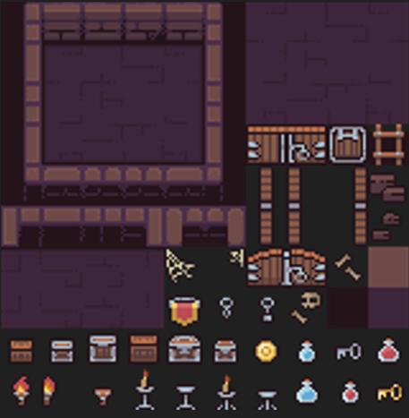

Figure 1 - Tilemap for room layout

The tilemap shown above is what will be used for the general layout of the rooms, and will primarily use the wall, floor and door tiles to create them. This has been chosen as it works well for the kind of layout that the rooms will have, as a lot of other tested assets did not work very well, or required a lot of finetuning to get it to look right in the game. This pack also works will with the general theming of the game, with the enemies and player sprites that I am going to use.

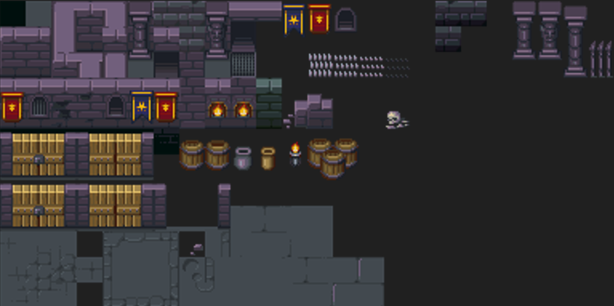

Figure 2 - Tilemap for obstacles

The tilemap below will be used for general things such as obstacles that the player and enemies will have to navigate around, to make the gameplay more interesting and add some more strategy to the game in blocking and avoiding enemy attacks.

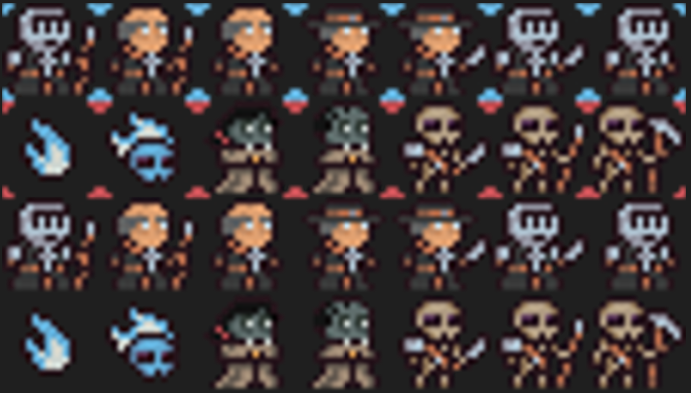

Figure 3 - Enemy and player sprites

I have chosen to use this asset pack for the enemies and player sprites in this game. This is primarily due to the lower budget of the game, making it difficult to find sprites that properly fit the sci-fi theming initially set out early in the report. In a future version I may choose to update the theming of the game with different sprites that more accurately reflect the theme of the game, travelling through different planets, however for the initial version, getting the core gameplay loop and mechanics working as intended is more important.

# Development

## Iteration 1 – Player Movement

### Design

Player movement is a core component of any top-down game, and ensuring that it works well can make or break the experience the user has when playing the game. For this reason, it is important that I get the factors such as responsivity and speed just right so that the player can easily manoeuvre the game area avoiding enemy attacks, while not feeling overly slippery from unresponsive controls.

The player movement will be 8 directional by using WASD inputs and allowing for diagonal inputs to be made by using 2 adjacent keys at a time. This will be done to give the player more control over their character, making it easier to avoid and manoeuvre around enemies than if they only had access to horizontal and vertical movement.

As I am still learning Unity at this stage, and have very limited knowledge on how C# game development flows, I have chosen to use Brackey’s movement guide to give me some basic ideas on how components, methods and libraries work within Unity, to help with this part of development. (Brackeys’ movement guide, <https://youtu.be/whzomFgjT50?feature=shared>). However, as I want to ensure that my game feels unique to play, I will make some changes to the script to modify it slightly, changing the values and the way the player moves slightly.

The player movement will work by getting the raw axis values for the horizontal and vertical axis’, which are either positive or negative 1 in each direction. These will then be multiplied by the movement speed, with a force added to the players sprite using a 2D RigidBody component placed on the player, moving the player forward with a constant force.

**[INSERT FLOWCHART FOR MOVEMENT]**

Once I have implemented the movement, and ensure that it is working as intended, I will add the player’s animation so that the sprite looks livelier and less robotic. As well as this, there will have to be a small script that flips the player’s sprite depending on which way they are moving, either left or right.

#### Test Plan

|  |  |  |
| --- | --- | --- |
| Test No | Test | Expected Result |
| 1 | Player collision | Player collides with walls |
| 2 | Player movement | Player can move in 8 directions |
| 3 | Player speed | Player moves at the same speed in all 8 directions |
| 4 | Player sprite | Player’s sprite flips direction to the direction they are moving in |

### Implementation

#### Creating Play Area

The first thing I did in this phase was create the play area that the player would be moving around in. It was important that I did this early so that I could tell that the player was moving correctly, and also gauge how fast the player was moving relative to the size of the room.

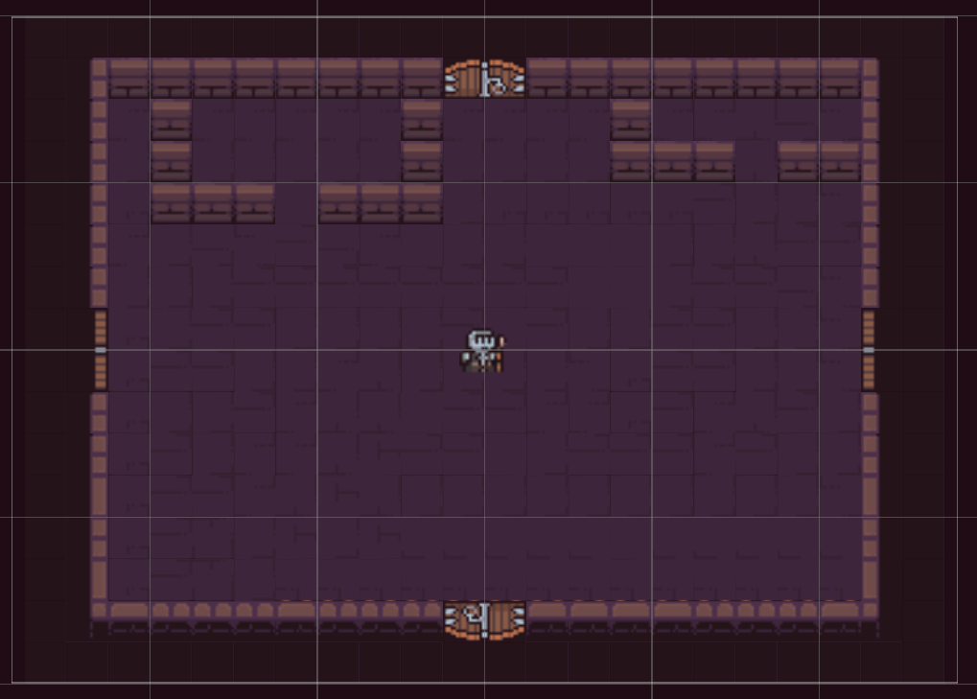

To create this map, I simply used the tile palette to drag and drop the tiles onto the scene.

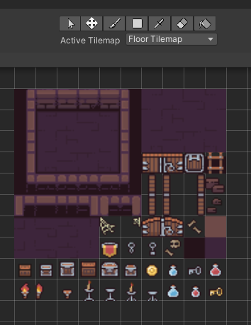

It took a while to get this working as intended, as I had to make the tiles the correct size to fit the palette, so that each square in game was the same size as a single tile on the asset pack.

I also had to spend some time working with layering when creating the map, as each part of the map is on a different z coordinate within the scene, so I had to experiment with what objects to have on what layer to make sure that everything collided properly and was actually visible within the scene. I ended up having the floor on z = 0, the doors on z = -1, and the walls on z = -2, with the player being on -10 to ensure that it would always be displayed on the top no matter what else was put onto the map.

Each section on the scene was created within a different game object, allowing me to give different properties to different parts of the map depending on their purpose.

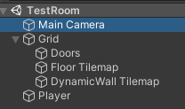

As shown above, I had 3 different game objects within the main grid, the doors, the floor, and the walls. The doors were simple, simply the 4 doors on either side of the room, that will eventually be able to be either enabled or disabled once the enemies in the room had been defeated.

Both the walls and the door had colliders added to them, preventing the player from walking through them. This also required adding a circle collider to the player, as colliders will only collide with other colliders, not just sprites. Shown below is a screenshot with all of these colliders, highlighted in green.

A circle collider was chosen for the player as it meant that they would not get stuck on walls and inside slide across the collider, moving perpendicular to the direction they are moving in to go past the collider.

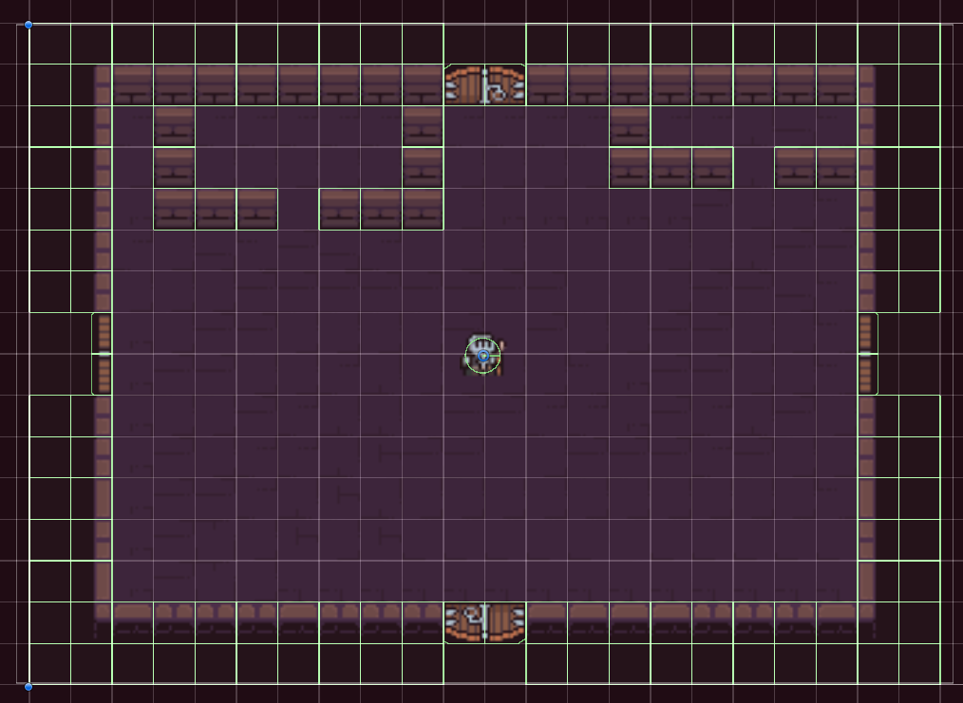

#### Player

Now that the room and collisions had been created, I could begin work on the script for the player movement.

I needed to add two components to the player sprite, a RigidBody 2D, and a script for the movement code itself.

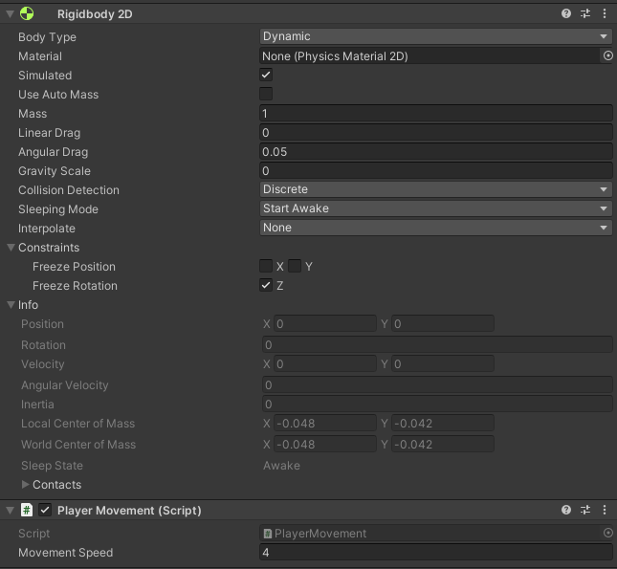

The RigidBody is used to give objects physics, allowing forces to be added to the object and making it behave like an object in real life would. In 3D, this would also mean putting the object under the influence of gravity. This was also the case in 2D, where the sprite would fall downwards in the y axis to hit the bottom of the map, as shown below.

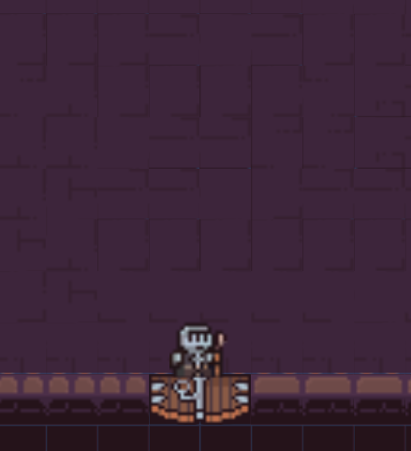

This is fixed by changing the gravity scale of the object to 0, so that it stays stationary in the scene unless another force is added to it.



#### Movement Script

Within the PlayerMovement script, the first thing I did was initialise the variables that I would need for the rest of the class.

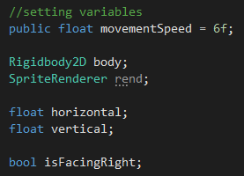

The public modifier on the movement Speed variable is very useful as it allows it to be seen by other classes, as well as in the Unity inspector for the object the class is held on. This is beneficial as it allows me to test different speed values at runtime, without having to close the game, change the value manually, and then restart the game. When changing the values at runtime through the inspector, it hot reloads the game, making the changes immediately take effect.

The two variables with the green text before them are references to types of components. In the start function of the class, these variables are assigned to the respective components that the sprite holds.

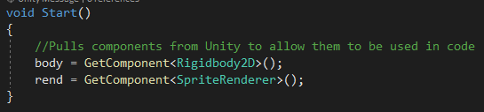

The horizontal and vertical variables will be assigned either positive or negative values for the player moving in a positive direction (up or right) or a negative direction (down or left), that can be multiplied by the movement speed to get an overall force that will move the player in a specific direction.

This is shown in the code below, where the raw axis value of the user’s input (Unity has WASD as default keybinds for this) and sets it to the respective variable for the axis the input is affecting. All of this code is contained within an Update function, as I want it to be collected every frame while the game is running, so that there is minimal input lag when pressing keys.

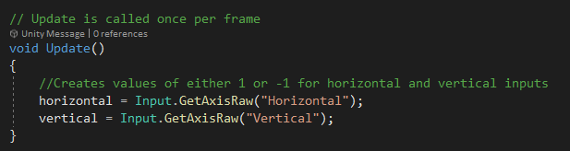

The following code is the code that is executed on a FixedUpdate schedule, meaning that for every frame that the game shows (as set by the capped framerate of 60fps, 120fps etc.), the code within the method will be executed.

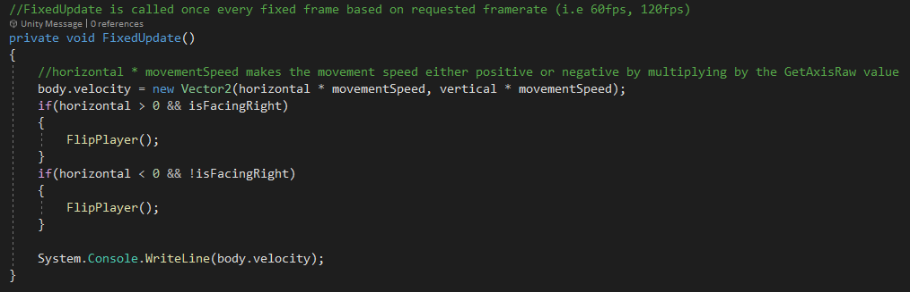

The first line of this method sets the velocity of the sprite’s RigidBody component (variable “body”) to a vector2 value (a datatype that contains an x and y value, linked to the x and y axis within the game). This vector2 takes the x value as the horizontal value (either 1 or -1), and multiplies it by the movementSpeed (in this case, 6), to get a final value of either +6 or -6, with the positive 6 moving the player to the right, and the negative 6 moving the player to the left. This is also done for the y values of the vector. As this is called every game frame, as long as the player is holding down a directional key, they will keep moving in the same direction until the frame they let go, at which the velocity of the sprite will be set to 0, as the direction variable will be set to 0.

This method allows the sprite to move in 8 directions, as horizontal and vertical keys can be held simultaneously, having the velocity on the x and y axis to both be set to +-6.

The final thing related to the player’s movement is the flipping of the player left and right, depending on the direction they are moving. This was done using a small method called “FlipPlayer” that would change the players direction every time the direction changes.

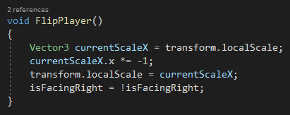

This script works by setting a vector3 variable to the localScale of the player, which contains information on the scale of the player’s transform (location, scale, etc.) relative to its parent game object. This allowed me to collect the x value of the player’s scale, and invert it by multiplying it by -1. Once this had been done, the script would then change the isFacingRight variable to the inverse of itself, which would then be used within the original if statements as conditions for when to execute the method, alongside a check that looks for the direction the player is moving in.

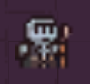

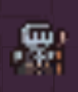

### Testing

|  |  |  |  |  |
| --- | --- | --- | --- | --- |
| Test No | Test | Expected Result | Actual Result | Retest Required? (Y/N) |
| 1 | Player collision | Player collides with walls | Player collides with walls | N |
| 2 | Player movement | Player can move in 8 directions | Player can move in 8 directions | N |
| 3 | Player speed | Player moves at the same speed in all 8 directions | Player moves faster in all diagonal directions | Y |
| 4 | Player sprite | Player’s sprite flips direction to the direction they are moving in | Player’s sprite flips direction to the direction they are moving in | N |

#### Retest No 2

One issue that was experience with the movement mechanic, was that when the player moved diagonally, as in, was holding adjacent horizontal and vertical keys at the same time, the forces would be added together, resulting in the player moving faster than intended. If left in, while potentially being interesting from a movement tech point of view, it brings in inconsistencies in gameplay that would be better off removed to make the gameplay more enjoyable and predictable, as the player should be able to know exactly what will happen when they make a specific input.

To fix this, I had to use a method called “ClampMagnitude”. This method takes two arguments, one for the value you want to clamp, and another for the maximum value that you want that value to be clamped to.



For example, if the player had a velocity of 10 and a movement speed of 6, the code would recognise that 10 is greater than 6, and limit the velocity to 6, stopping the player from moving faster than the movement speed.

The result of this is that the player now moves at the same speed no matter what direction they are moving in, making the gameplay more consistent.

### Evaluation

Overall, this iteration was a success, with minimal issues throughout its implementation. The only major bug that was found was an easy remedy and simply a logic error that could be fixed with a minor design change. The rest were simply issues that arose due to a lack of experience with the engine and just required getting accustomed to how things worked and how different things worked within the environment.

This iteration was great at giving me some basic knowledge on the Unity engine that will be beneficial in the rest of the project, with some simple and understandable code that I can use as the foundation to begin creating the more complex algorithms that will be necessary later in the project.

While the movement system I have implemented here is enough for this version of the game, one thing I would have liked to implement is a change to the responsivity of the movement, making the player not immediately change direction when a different key is pressed, instead having the player slow down before changing direction, as this would make the game feel a little more polished due to the extra physics in play.

In the initial requirements specification for this project, I stated that the player should be able to move in all 8 directions. As this was the only user requirement for this section, I can conclude that this iteration was a success.

As for the iteration’s maintainability, it is all confined within a single class attached to the player game object. I cannot comment for how this will hold up later in the project, as many more classes and objects will be implemented, with a lot of links and references between those classes so that they can communicate as required. In its current state, however, the class has a lot of scope to be expanded upon and used in any way it is required.

## Iteration 2 – Player Attack

### Design

Player attacking will work in 4 directions, irrespective of what direction the player is facing or moving in. The attack will work by pressing any of the arrow keys, with projectiles being fired in the respective direction in set intervals. These shots will be created from a prefab object, consisting of the projectile asset, a glow effect, and a collision hitbox.

This prefab will then be instantiated as a clone with the required forces based on the direction it is being fired in, and will be destroyed when it meets with another collider.

Once enemies are added, further functionality will be added to either the projectiles themselves, or the enemy class, detecting whenever a projectile collides with the enemy’s hitbox, triggering an event to reduce the enemy’s HP.

Shown below is a flowchart of how the game will check what direction a projectile should be fired in. I had initially considered using a switch case for this operation, as they do not have to check each individual case, instead simply jumping directly to the case that is true. However, this is not possible with string, so instead it is easier to have 4 separate if statements that are called every frame to check for when an input is given for firing a projectile.

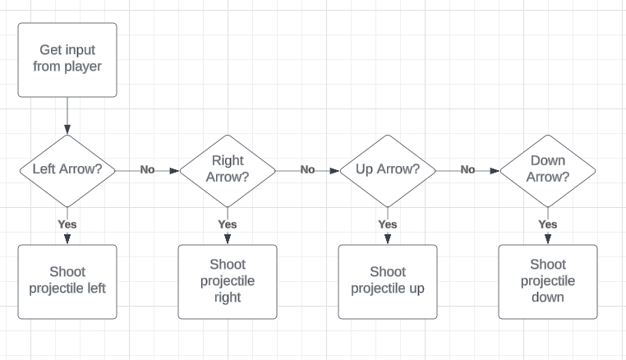

As I am still new to the Unity engine at this stage, as I was in the movement iteration, I have decided to use an online video to help with some of the core concepts of this iteration. The main reasoning behind this was to learn prefabs, and how they can be utilised within a project. I had wanted to design my projectile script entirely from scratch, however due to the simple nature of the iteration, it proved hard to find a way to deviate from the methods shown in the video without purposefully and needlessly increased the complexity and decreasing the efficiency of the solution. As with the movement iteration video, the video involved with the design of this iteration can be found in the additional evidence folder alongside this report.

### Implementation

The first step to creating an attack system was to create a projectile prefab that would be instantiated whenever the player attacked.

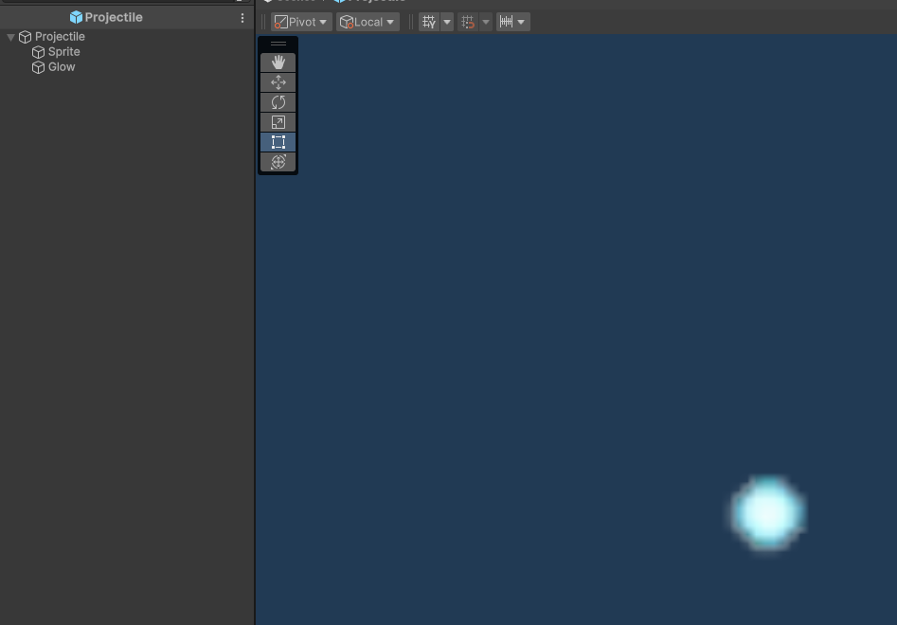

A prefab is created by creating a game object and dragging it into the project itself to be saved. This can then be instantiated whenever it is needed using the “Instantiate” method built in to Unity.

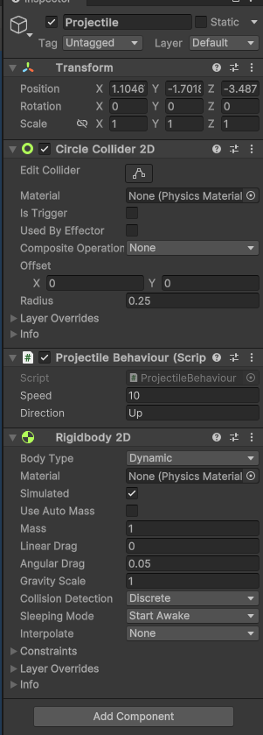

The parent “Projectile” game object is just an empty object that contains the sprite itself. This object is what holds the physics components and scripts for the projectile, as well as the child sprite and glow objects.

Due to the extra functionality that will be added to the player movement class in this iteration, I decided to rename the class to “PlayerBehaviour” as it will include more things than just the player’s movement, and will encompass everything directly related to the player, such as the player’s attack, as there are a lot of overlapping variables that are used, and it makes more sense to have everything related to the player held within a single class for ease of development.



Shown above is a reference within the player behaviour class to the ProjectileBehaviour class, the class that is attached to the projectile prefab. Doing this allows me to use or change any public variables or methods within that class and use them in the player behaviour class. One use case for this is shown below, utilising the public direction variable to change it to the direction that the projectile will be moving.

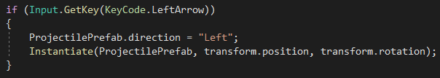

This is the initial version of the instantiation for shooting projectiles to the left. The condition for the if statement uses keycodes, which are the keys assigned to specific keys within Unity itself. This is useful as it allows for better maintainability when it comes to rebinding keys, as the keycode can be different than what the keys actually are. In this case, the condition is met when the keycode for the left arrow is pressed. Within the if statement, the first line sets the public variable for the direction of the projectile, within the prefab that is about to be instantiated. This works because the prefab that is created in the instantiation will be the current version of the prefab. This means that if I modify it before creating it, then it can be instantiated with different values, in this case, the variable for direction being set to go to the left.

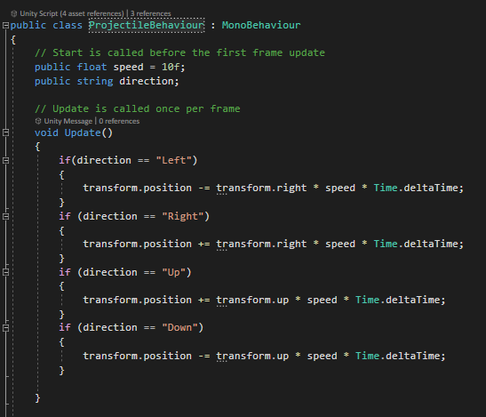

Within the ProjectileBehaviour script, there is an if statement that is called every frame that moves the projectile created in the direction of the direction variable. As the same script is being used on each projectile, regardless of its direction, I needed 4 different statements for each direction the projectile could move in. Within the statements is a line of code that sets the position of the projectile to itself, plus a vector in the direction it is moving. This vector is only by a unit of 1 in any direction, which is multiplied by the speed, in this case 10. This means that each frame, the projectile will move 10 units in the direction it is travelling.

The Time.deltaTime essentially stabilises the movement of the projectile, making it consistent regardless of the actual framerate of the game. Without Time.deltaTime, a faster framerate will make the projectiles move faster, as there are more frames that will be called, adding the vector more times in the same amount of time. By multiplying by Time.deltaTime, it modifies how much is added to the projectile’s position based on the framerate. A lower framerate will make the distance travelled per frame higher, and a higher framerate will reduce it.

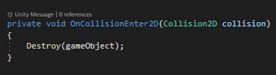

In the projectile behaviour class, I also added a collision detector, which would destroy the game object whenever its hitbox collided with another one. This was done with the intention that whenever it hit a wall, it would be removed from the scene.

When testing this code, however, the projectiles began getting destroyed immediately upon being created. This ended up being due to the hitbox for the projectiles colliding with the player’s hitbox.

To fix this I added a position offset to the player’s attacks, making them be created slightly away from the player’s sprite and hitbox to prevent them from being immediately destroyed.

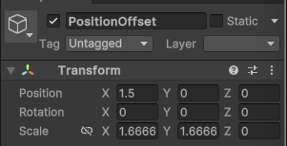

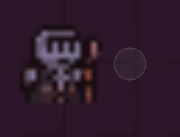

This offset (the grey circle to the right of the player) is just an empty game object that will be used as the reference for where the projectiles will be instantiated, instead of previously how they would be created from the player’s position.

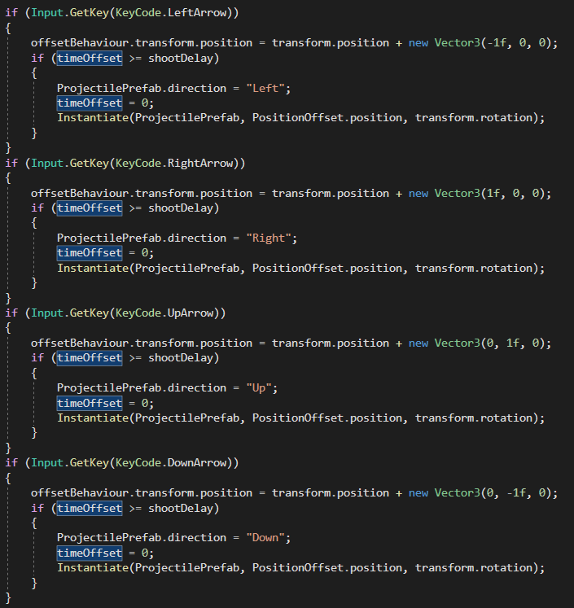

Figure 4 - Original Movement Script

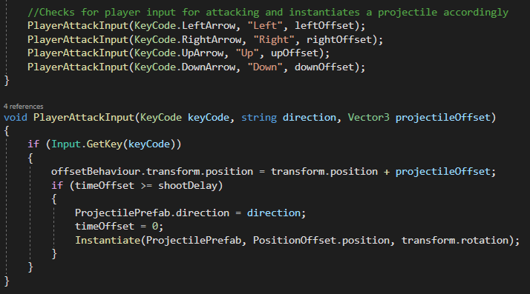

Figure 5 - New Movement Script

### Testing

### Evaluation

## Iteration 3 – Map Generation

### Design

The design for this section of the game was partially collaborated on with my classmate. Together, we discussed the general flow of the algorithm, of which some design choices made it into the final design, and others were modified slightly or removed in favour of alternative approaches.

The room generation system will draw a lot of inspiration from the game “The Binding of Isaac”. That game consists of multiple rooms linking off of one another, each with 1-4 doors branching off into other rooms. I figured that the best way to create this system was to look at how rooms were generated in that game and attempt to replicate the process in my own design.

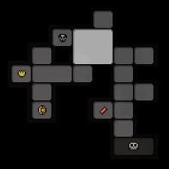

Above is an example of a map generated in the game. Each room has between 1 and 4 rooms connected to it. However, as you can see in this game, some of the rooms are larger than the others, taking up either 2 or 4 rooms total. I thought that for this initial version of my game, it would be best to stick to generating only a single size of room, as the developers of Binding of Isaac stated that it was a very difficult task to implement properly, and is something that would be out of my timeframe for this project.

Shown below is a complete flowchart for the process that will be followed for the room generation, from creating the rooms to removing the doors after the rooms have all been created.

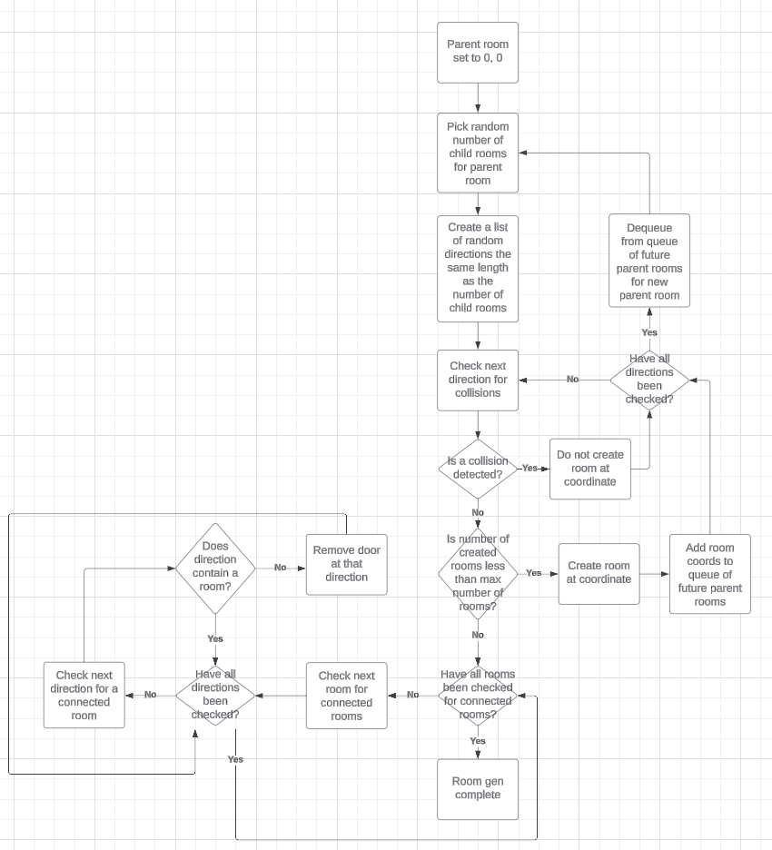

This flowchart is a little complicated, so I expect to run into a lot of difficulties despite the extensive planning that has been carried out to simplify the process. The primary goal of this section is to create a room generation system that works, even if a little inefficient. Any inefficiencies can be ironed out in future versions after this project has concluded.

#### Coordinate System

The first step in the design of this system is to create a coordinates system for each of the room placements. As each room has the same size, it means that it can fill into a box, with each room taking up a coordinate value of that box. For example, the first room the player spawns into will have coordinates (0,0). The room to the right will have coordinates (1,0), the room above that will have coordinates (1,1) and so on. This will make the building of the map much easier as rooms can simply be instantiated into those coordinates without having to directly worry about where they will be placed in the engine’s coordinates, with the camera following them as they do so.

#### Stages of Map Generation

Map generation will consist of a couple major steps. The first step will be the creation of the map itself, by utilising a queue of future parent rooms that will eventually have child rooms created from them.

Once these rooms have all been created and placed into the scene, then a script will run that will remove all of the doors from the scene that are not required to move to another room. This will make it so that the player cannot escape the map and go out of bounds.

#### Creation of Map Layout

The first step in creation the layout will be to create the starting room, which will always be at (0,0) using the rooms coordinate system. Alongside the instantiation of this room, a number will be picked from a list of numbers, ranging from 1 to 4 (these numbers will be weighted so that rooms with only 1 child and rooms with 4 children are less common. While useful for if the newly created room has no children, if it does, then it may cause issues with overlapping rooms as the algorithm will attempt to add rooms onto coordinates where there are already existing rooms. An example of this is a room that is to be generated where it will already have 4 children. Once it has been instantiated, the algorithm will decide how many child rooms it should have, and if it chooses 4, then 4 rooms will be created on top of the already existing ones. To remedy this, I will run checks before the rooms are created to ensure that there is not already an existing room at that coordinate. If there is, then the room will be removed from the list of coordinates, and a room will not be created there.

The process of creating rooms will end once the maximum number of rooms has been reached. The maximum number of rooms will be determined by a variable that will increase as the player progresses through the game and the different planets, as each planet will consist of one iteration of the map generation, each time the player completes a level and progresses to the next the variable will grow along with the difficulty of the level and its enemies.

Each level in the game will have a single boss room that, once defeated, will allow the player to progress to the next level. These boss rooms will be spawned once the maximum room number has been reached, and will be assigned the room furthest away from the origin coordinates, encouraging the player to explore more of the level before it is completed.

At the end of this process, there will be a set of clones created in the project hierarchy with their associated coordinates. These objects will be placed into the scene in their respective coordinate, to allow for the room to be placed on top of them in the next stage of generation.

#### Removing doors after generation

Once all of the rooms have been creating for the level, I will have to remove any doors that do not lead to other rooms so that the player cannot walk out of the map. This will be done by running a check on all of the rooms, much like during the initial room generation, to see if they do or do not have a room connected to them. If they do, then the door will remain, if not, then a wall will be placed on top of the door, by enabling the renderer and collision for an already placed wall included in the prefab of the room. While not disabling the door, it will prevent the player from moving through as an extra layer of collision will be present that will not be disabled when the doors are removed after defeating all of the enemies.

#### Enabling and disabling doors

Whenever the player enters a room, all of the doors will be closed, to force the player to defeat all of the enemies in the room. Once this is done, all doors will open. Taking into consideration the fact that I have 4 different door presets, corresponding to the left, right, top, and bottom doors, this means that I have to find a way to affect all of these doors simultaneously. The best way to accomplish this would be to add a tag called “doors” and have the code search for all objects with the same tag, and disable both the renderer and hitbox of the object when the enemies are defeated, so that the player can walk through.

#### Test Plan

|  |  |  |
| --- | --- | --- |
| Test No | Test Name | Expected Outcome |
| 2 | Weighted list work | Number in the first array containing numbers 1-4 are multiplies by the respective index in the probability array |
| 1 | Setting number of childRooms | Whenever a room is created, a random number between 1 and 4 is set to the childRooms variable. |
| 2 | Individual rooms generation | Individual rooms can be created and put into the game world by calling the create room method along with the game coordinate to create the room on |
| 3 | Room gen | Rooms get created and put into the game world according to their assigned coordinate relative to the parent coordinate |
| 4 | Room collisions | Rooms do not get created on top of any other rooms that already exist |
| 5 | Room gen limit | Room generation stops once max number of rooms is reached |
| 6 | Door removal | All doors are removed for directions that do not lead to another room |
| 7 | Boss room | Boss room is created in the furthest room away from the origin room |
| 8 | New map generation | Once the boss is defeated, a new map will be generated with a larger number of rooms than the previous level |
| 9 | Child Rooms | Random number of child rooms is selected for each created room |
| 10 |  |  |
| 11 |  |  |
| 12 |  |  |

### Implementation

#### Opening/Closing Doors

As enemies have not yet been created, there is no way to control the opening and closing of the doors in the game. For testing purposes, it would be beneficial to allow the player to open and close doors using a keybind to allow them to navigate the map easily to view the different rooms and the layout that has been created.

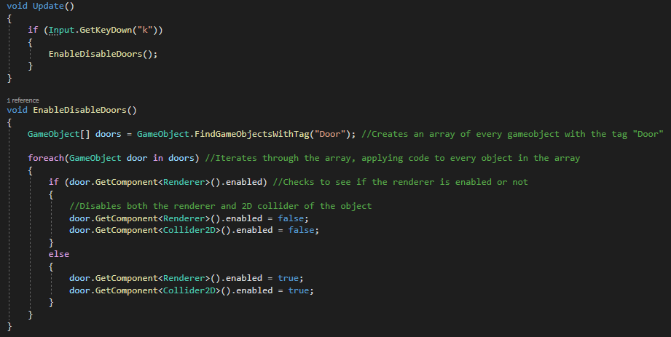

As shown in the image above, this algorithm works by creating an array of all the GameObjects that have the tag “Door” and enabling and disabling the renderers and colliders of every object in the array.

One issue with this code, however, was that the doors would open and close every single frame for as long as the “k” key was held down. This was due to the condition for executing the procedure was met for as long as the key was held down, as it was only checking for an input.

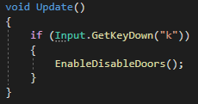

This error was fixed by changing the “GetKey” method, to “GetKeyDown”, which simply checks whenever the input is initially made, and returns true on the first instance of the key being pressed, and false for all the frames after until it is released and pressed again. This made it so that the doors did not constantly open and closed, and only did it when I pressed the key.

#### Coordinate System

The next thing I wanted to implement was the coordinate system that would be used to determine where rooms would be placed in the scene. To do this I had to create various rooms attached to the first test room to find their respective x and y values.

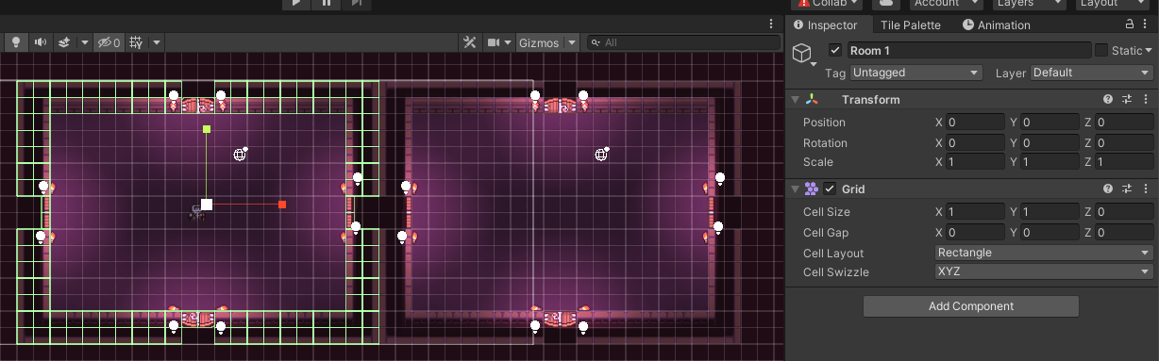

As shown above, the first room has an overall position vector of (0, 0, 0), meaning it is centred at the origin of the scene.

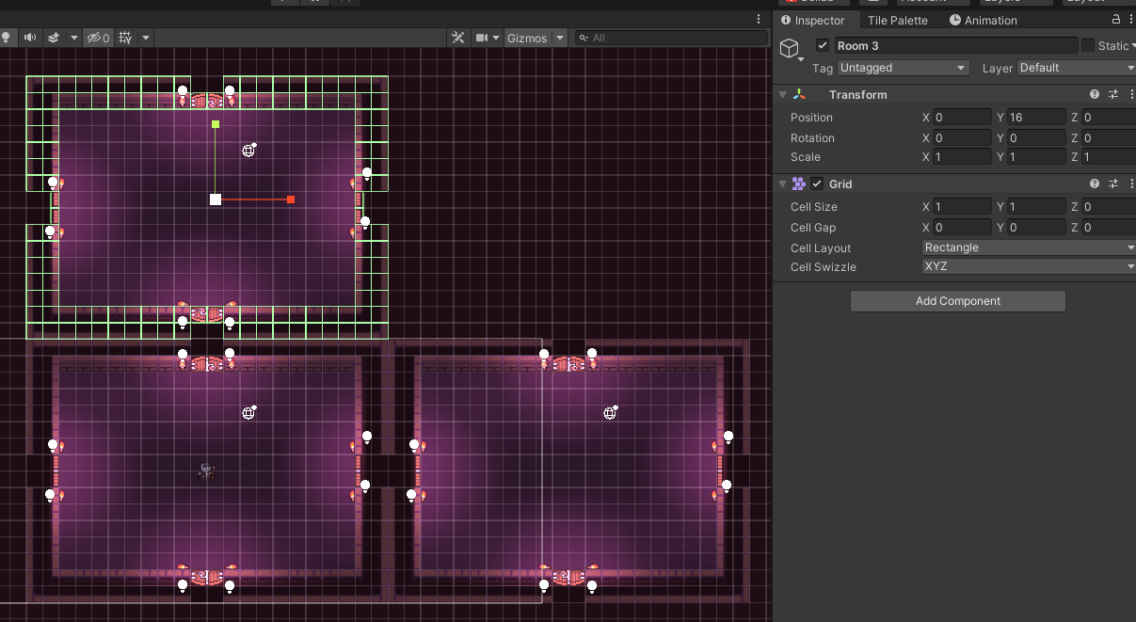

Room 2 shows that the centre of each room along the x axis will be 22 units greater than the previous. Room 3 also shows this but for the y axis, which each room being 16 units great than the one below it.

This meant that I had to make a way for any vector entered in regard to room location, was multiplied by 22 and 16 in the x and y axis respectively whenever it was ready to be interpreted by the engine.

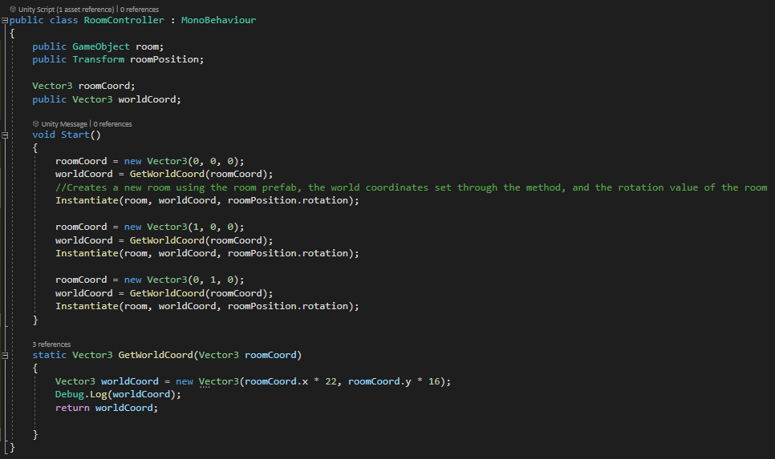

The image above shows the RoomController class. This class will be responsible for the creation of the rooms and the overall map of the level. In the initial test, to ensure the coordinate system works properly, I simply created 3 rooms using the system to test that they were all placed in the right location. Executing this code, however, had some interesting results.

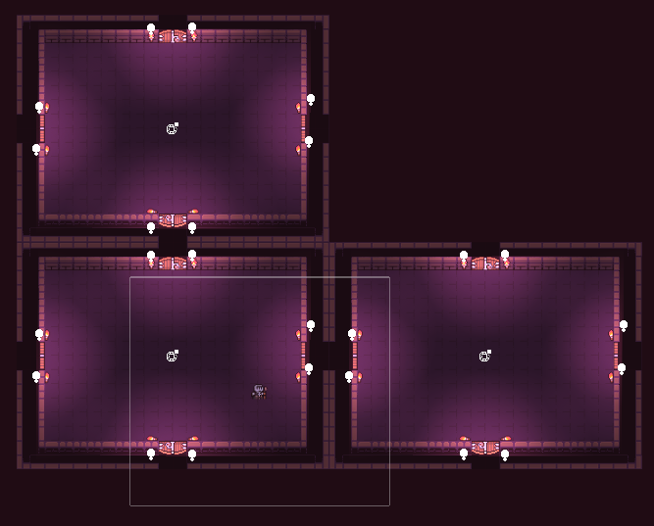

First of all, in the scene view, the 3 rooms were created and placed on the map in the correct locations relative to each other, but not at the origin where the player is. This is peculiar, because both the starting room and the player supposedly have the same coordinates according to the Inspector tab.

This was fixed by going into the parent object for the room, and changing the position of that to the origin of 0, as it was not previously set to that, resulting in all of the instantiated rooms being offset by that amount.



The second interesting event was that in the game view, all of the rooms are invisible to the player, despite still being rendered in the scene. In the end, this was due to the camera being positioned at the z value -1000, which was what I was using in the initial creation of the room at the start of development. After changing the z coordinate to 0, the rooms were visible on the game view.

#### CreateRoom Method

I wanted to create a way to instantiate rooms in a single line of code, to simplify the process of creating rooms for later in the algorithm.

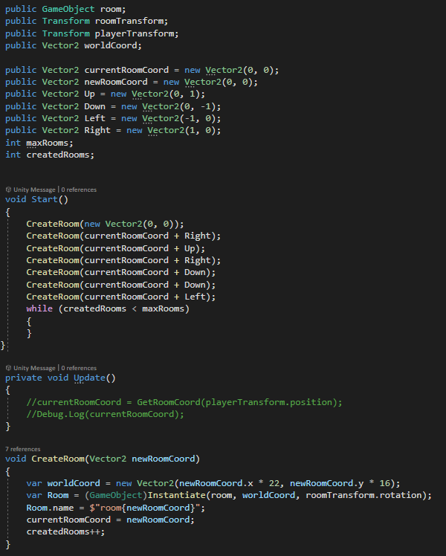

As shown above, this was done by creating a method called “CreateRoom”, which manually converts the roomCoord variable into its respective world coord, then instantiates a room with the room preset and position, before renaming it and setting the currentRoomCoord to the coords of the room just created. This means that when the method is called, as shown in the Start method, the currentRoomCoord can be used again and again, with directional values that will create a new room in the direction relative to the room just created.

This helped greatly in forming a solid foundation that would be expanded upon throughout the development of the algorithm.

#### Creating Camera Movement

In order to navigate the rooms created when the game begins, I have to make sure that the camera is able to follow the player across the map. This will be done by changing the camera’s position to the centre of the new room that the play enters.

The first step in this process was to get updates on the room coordinate relating to the players position in the world.

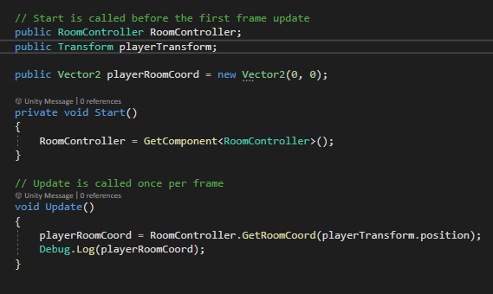

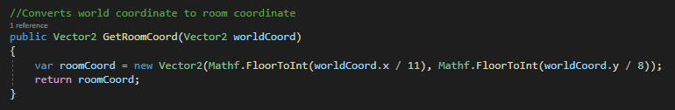  
While this worked mostly as intended, updating the coordinates of the player, the coordinates ended up updating and increasing by 1 for every half room the player explored. If I changed the values to 22 and 8 respectively, then it would result in the coordinate updating whenever the player entered the centre of the new room.

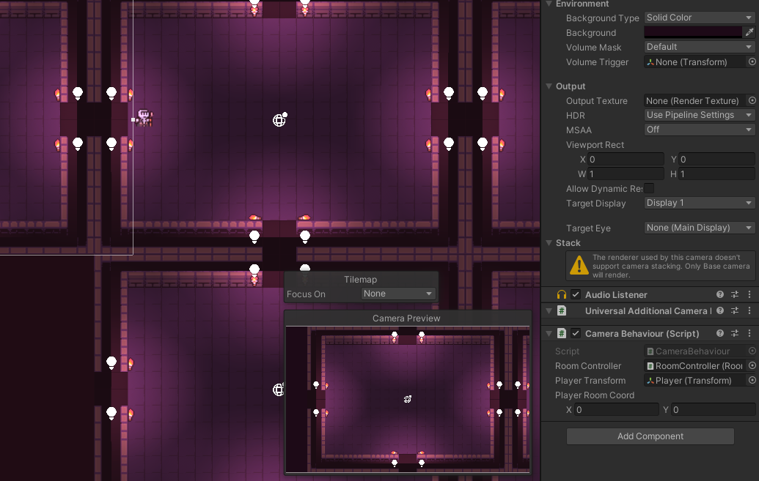

As you can see above, the player is in room (1,0), while the Player Room Coord variable is still showing as (0,0) on the bottom right of the screen.

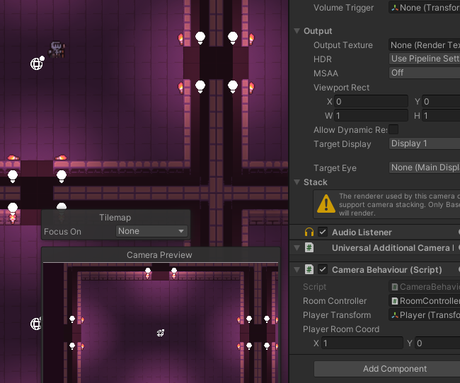

To fix this, I had to think of the world coordinate to room coordinate as an equation. This ended up with the form roomCoord.x = ((worldCoord.x + 11) / 22 for the x axis, and roomCoord.y = ((worldCoord.y + 8) / 16 for the y axis. This was due to the offset of the rooms being placed in the centre of the origin, so this had to be artificially corrected by adding half of the width/height of the room to the coordinate.

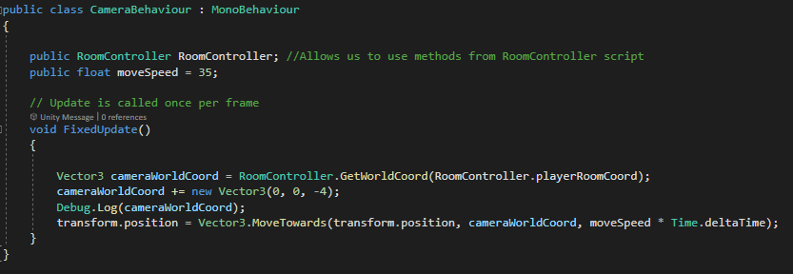

The above code works by first setting the cameras world coordinate to the world coordinate of the room the player is currently in. Once that has been set, for testing purposes a debug.log line is ran to confirm the coordinates, before setting the position of the camera equal to its target coordinates. The “MoveTowards” method is used here to move the camera gradually to its destination, over the time defined by the third parameter of the method call.

#### Picking random number of child rooms

The first sizeable step in the flowchart shown in the design phase is picking a random number of child rooms. While in the design phase I explained that I wanted this to be a completely random choice, with each number of child rooms having the same change of being chosen. However, after thinking about how this would look in game, I decided to modify it so that rooms with 2 child rooms were more common than the rest, as it would create a map that was more spread out and less condensed, meaning that the player would have to travel further to reach where they need to go, increasing playtime and encouraging them to memorise the map layout more than if it were all together.

The first thing I did to implement this was create a Room class that would hold all of the code related to each individual room. The class was added as a script to the room prefab, meaning that each time a room was created, the code within the class would be executed and assign all the values required for that room, such as, in this case, the number of child rooms the room would create when its turn arrived.

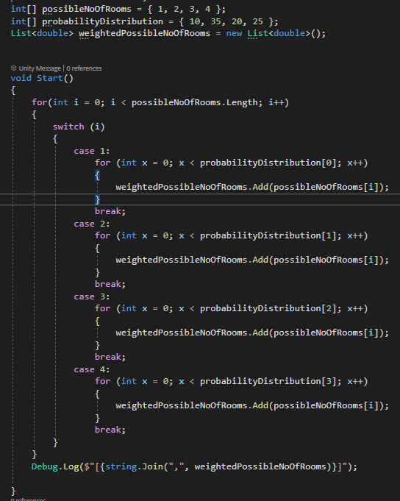

To set the number of child rooms for the room, a switch case statement was used to multiply the value of an index of the possible number of rooms array by the value of the respective index in the distribution array. The purpose of this was to create a large list of numbers, assigned to the variable weightedPossibleNoOfRooms, where some appear more frequently than others, increasing their chances of being selected in a pick random statement when being used to assign the variable for the number of child rooms.

While this worked mostly as intended, there was an issue where the number 1 did not appear anywhere in the array, with the other numbers being selected an incorrect number of times, as shown below.



This was fixed by reducing the number on the cases in the switch case statement, as it was using the case for the next index value, which was not intended. Corrected code can be seen below, along with the result of the algorithm when it is run.

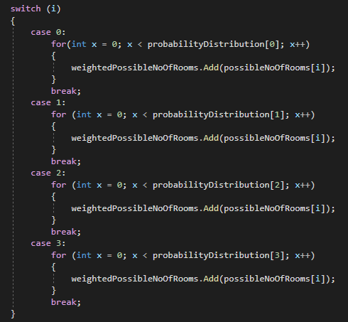



Once the list was being created successfully, I created another method for getting a random index from this list.

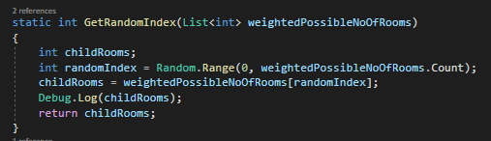

This was a fairly simple method to make, creating a local variable for the number of child rooms, another variable that would store a random index value from the weighted list, followed by setting the value of the childRooms variable to the value stored within the chosen index in the list. It then returns the value of childRooms as the output, allowing any variable to be set to it when called at runtime. This is done as shown below. For demonstration purposes of the method, I added a condition that the code would execute on every press of the “h” key, to see how the number of child rooms changes each time.

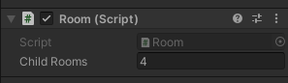

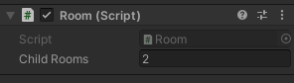

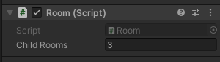

#### Creating generation procedure

##### First Version of algorithm

Due to the complexity of the generation algorithm, any planning ahead of time would only work for logic, and the basic flow of the algorithm, as shown in the planning section with the method flowchart. This meant that implementation of the algorithm had to be primarily creating a section of code, testing how the game reacted to it at runtime, and making modifications accordingly to work towards a working solution. The first version of the algorithm is shown below in small sections. This version of the algorithm has minimal checks in place, and just creates the rooms as the procedure tells it to, without checking whether or not a room can actually be placed there.

The first large issue with the development of this version was Unity crashing due to the generation. The way I ended up finding the cause was by waiting for user inputs before executing the next iteration of generation, so that the engine had time to execute the instructions and finish what it was doing before continuing. The original version of this code is shown below:

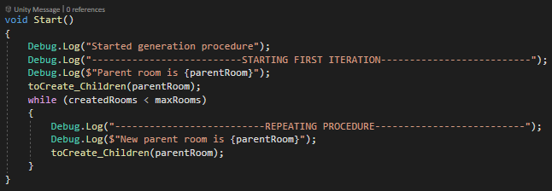

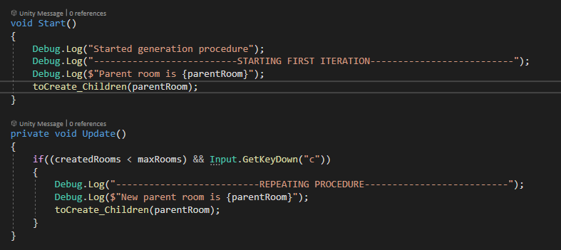

Shown above is the updated code, adding a check to wait for the user’s input before proceeding to the next generation iteration.

The code shown below is the method that is executed once the generation starts. Alongside logging the progress of the generation, it works by creating a direction list (shown in figure 6) using the number of child rooms the parent room has, and then checking that direction list against any rooms that already exist in the game and removing the rooms from the list if they already exist.

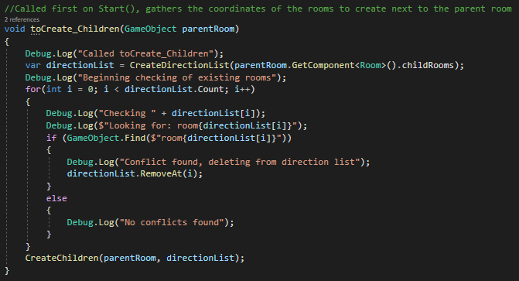

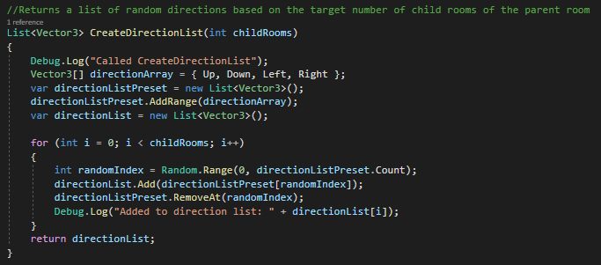

Figure 6 - Create Direction List method

Once the collisions have been removed, then the CreateChildren method is called, shown below. This method iterates through the direction list, creating rooms at each direction.

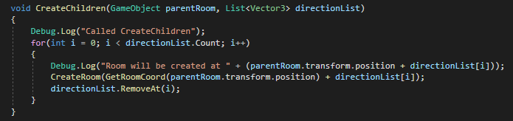

Upon testing this code, the game crashed immediately before showing it was playing. The Unity engine would go entirely unresponsive, requiring ending the task via task manager and restarting it. I decided to test this by adding a required key press to iterate through the creation of each room, so that it did not execute too quickly, overloading the engine.

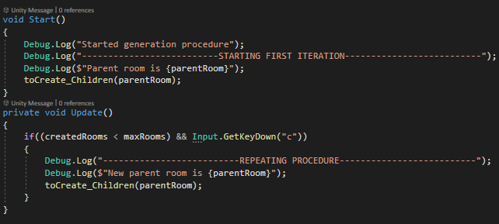

Above is the code used to do this, simply a GetKeyDown check for the C key so that the next iteration would only start when the key is pressed. This allows the game to run, and by pressing C multiple times, the following issue was shown:

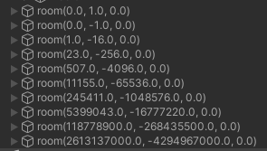

This showed that the room coordinates were getting exponentially bigger. On top of this, the coordinates in the name show the room coordinates of the room, which should be smaller, representing each room as its own unit in the x and y values. Instead, these values are being replaced with their world coordinates, which are then further multiplied by 22 and 16 when converting these values again in the CreateRoom method, as there is no validation in place to ensure that they are not already in world coordinate form, as this would impact the game’s execution when room coordinates naturally get to values that could be considered world coordinate. This resulted in unimaginably high or small numbers for the new room coordinates, which could understandably cause a crash when trying to generate them quickly.



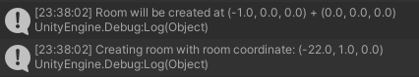

To fix this, I had to go to where the CreateRoom method was called, and take the room coordinate of the parent room’s position instead of the world coordinate as was taken originally.



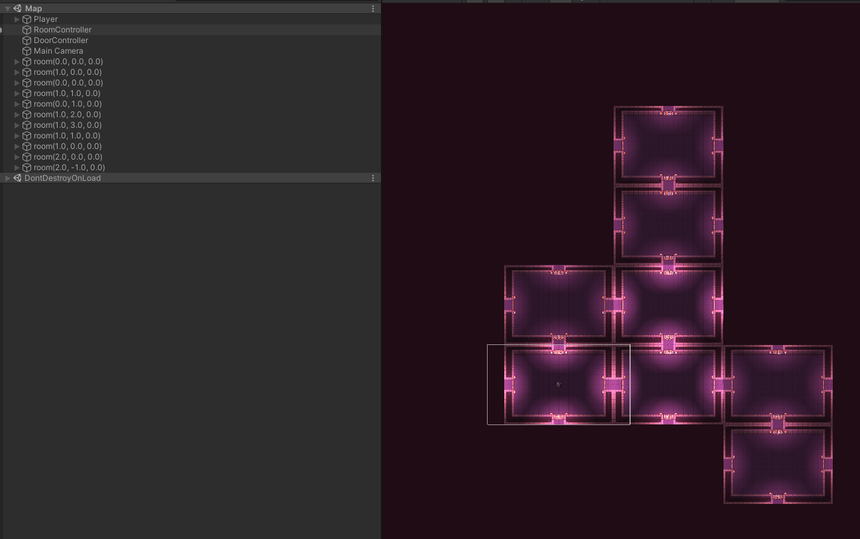

Once this was done, as shown above, the room gen worked as intended, meaning I could now take out the need to press “c” to continue the room gen, and have it be done automatically.

##### Testing

After creating the first version of the algorithm, having accomplished a rudimentary procedural gen that works mostly as intended, I decided to carry out a testing phase to see what features I had left to fix or implement, helping me to see exactly what I had to add and fix before moving on to the next iteration.

|  |  |  |  |  |
| --- | --- | --- | --- | --- |
| Test No | Test Name | Expected Outcome | Experienced outcome | Retest/Development required? (Y/N |
| 1 | Weighted list work | Number in the first array containing numbers 1-4 are multiplies by the respective index in the probability array | Weighted list is by multiplying arrays together. | N |
| 2 | Setting number of childRooms | Whenever a room is created, a random number between 1 and 4 is set to the childRooms variable. | Random index can be selected and set to the childRooms variable when the room is first created | N |
| 3 | Individual rooms generation | Individual rooms can be created and put into the game world by calling the create room method along with the game coordinate to create the room on | Room can be created by inputting the desired world coordinate | N |
| 4 | Room gen | Rooms get created and put into the game world according to their assigned coordinate relative to the parent coordinate | Rooms get created through the procedural algorithm into new positions to create a fully randomised map | N |
| 5 | Room collisions | Rooms do not get created on top of any other rooms that already exist | Rooms sometimes generate on top of each other | Y |
| 6 | Room gen limit | Room generation stops once max number of rooms is reached | Room generation stops once max number of rooms is reached | N |
| 7 | Door removal | All doors are removed for directions that do not lead to another room | Rooms are not yet removed once generation is complete | Y |
| 8 | Boss room | Boss room is created in the furthest room away from the origin room | No boss room is created within the room generation | Y |
| 9 | New map generation | Once the boss is defeated, a new map will be generated with a larger number of rooms than the previous level | User does not get sent to next level with more rooms once level is complete | Y |

###### Test No 5 Retest – Room Collisions

Room collisions ended up being a rather large issue within the room gen, taking several days of bug fixing and testing different approaches to get working as intended. Initially, I found that the condition for the if statement was checking the direction as a standalone vector within the game, instead of its direction added to the vector of the parent room. I also had to make this coordinate be read as a room coordinate to link with the usage of the directions. This is shown in the highlighted line in the below image:

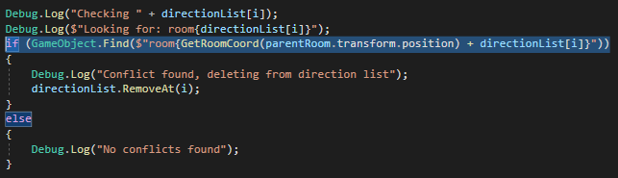

Once the basic generation was working as intended, with no actual collisions and rooms being created on top of each other, there were still a few small kinks to iron out with the algorithm. While not an error per se, as the room generation still generated 10 rooms in a random order, it was not working as intended relative to what I had initially hoped for with the child rooms.

To go into more detail, the issue was regarding other rooms generating rooms where other rooms had rejected due to not having the coordinates in their direction list. What this would result in, is that rooms could be made directly next to another room, ending in that room having a number of child rooms that is not equal to their intended amount. This meant that the generated map was much more central to the origin than I had hoped, with many rooms having 4 rooms connected to them, rather than being spread out, so the player would have to explore further.

To remedy this, I added a list for null rooms, for rooms which did not already exist, and were not a part of the direction list for the parent room. Whenever a new room would be created, it would check against this list to see if the coordinate was inside it. If it was, then the room would not be created.



The method below is called once the list of directions has been created, and detects and removes all collisions that have been found.

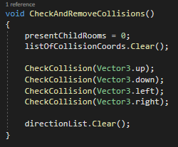

The present child rooms variable keeps track of how many rooms are currently connected to the room it is checking collisions for. This is beneficial as unlike the childRooms variable, it keeps direct track of how many rooms have actually been created and are connected to the room. The second variable for the present collision coords is then cleared, to remove any remaining collisions present from the previous iteration of the gen, followed by checking all of the collisions at each direction, direction by direction. During this process, rooms are created at each direction if the direction list contains them. After each direction has been checked and all the rooms have been created, the direction list can be safely cleared, ready for the next iteration.

Shown below is the first section of the CheckCollision method, which is a modified version of the original collision detection system, just refactored to make it slightly more readable and modular. The room is checked for the collision in the direction defined within the argument of the method call, and if it is present, 1 will be added to presentChildRooms, to indicate that the room has at least 1 connected room. It will then add the direction to the list of collision coords for that room, and then return the method without creating a room to progress to checking the next direction.

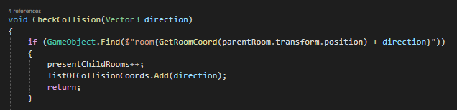

Once this has been done, and a collision has not been detected, the direction will be checked to see if it exists within the direction list, to see if a room should be created there. If it is not within that list, it is added to a list of null rooms, which are rooms that should remain empty for the rest of the generation. This list is then checked, returning the method if the direction is found in the list. These two if statements play a pivotal role in ensuring that the room generation is spread out and unpredictable, and not all confined in small space as the rejected rooms cannot be filled, reducing the number of rooms that can be created from future parent rooms for a valid trade-off.

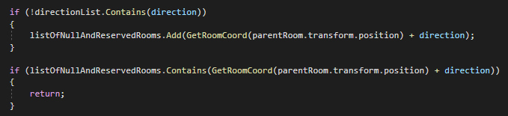

Shown below are two examples, one without the null list, and one with the null list, so you can see the difference in the gen between the two versions.

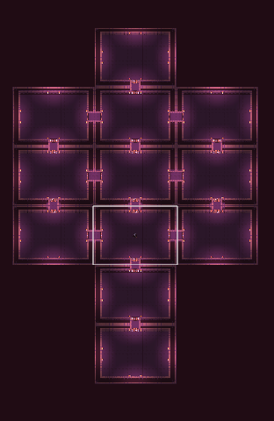

Figure 7 - Without null list

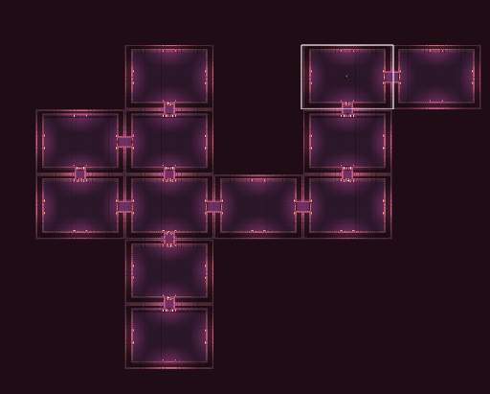

Figure 8 - With null list

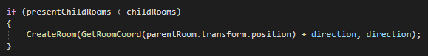

This statement above checks that the number of rooms connected to the room is less than the number of rooms it wants to have connected to it. This solves the issue where a room may want 2 child rooms, to the left and downwards. If the room already has a room to the right, it will still create both of those rooms, leaving the room with 1 more room than it wanted. This if statement prevents that from happening most of the time, however as the created room does not add 1 to the presentChildRooms variable, it means that created rooms do not count towards the collision total, skewing how many rooms are actually created by a small amount. Funnily enough, after testing gens both with and without this increment, I actually ended up preferring the look of gens without it, as they were less predictable and more randomly generated, without many long and straight lines that would cause unnecessary backtracking for the player, which would negatively impact their experience with the game.

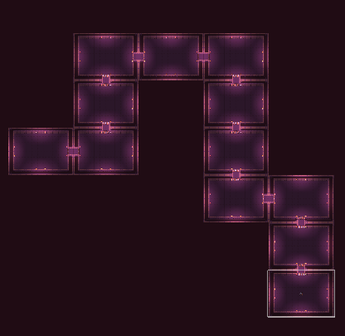

Figure 9 - With increment

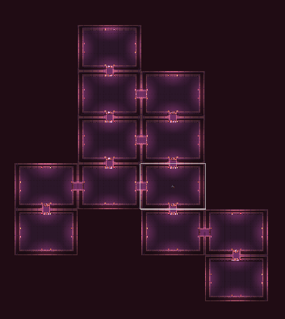

Figure 10 - Without increment

One final thing with the collision detection system, was that on very rare occasions, the gen would lock itself, as shown below:

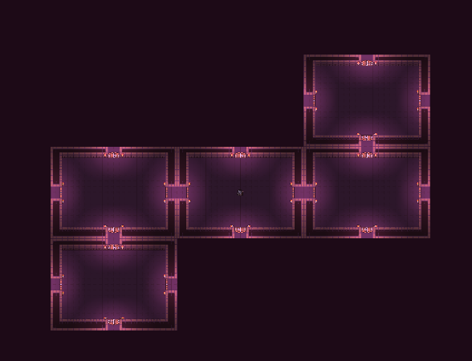

Thinking from the eyes of the algorithm, it makes sense how this could occur. The room in the centre wanted 2 child rooms, which have been created. The room on the bottom left also wanted 2 child rooms, same with the top right. In the bottom left’s case, it wanted to create a room above it, and to the right of it. This is an issue as the top room has already been filled, and the coordinate to the right has been placed in the null list due to a room not being created there by the centre room. The exact same thing has happened on the right side as well, completely locking the generation.

The image below shows this visually:

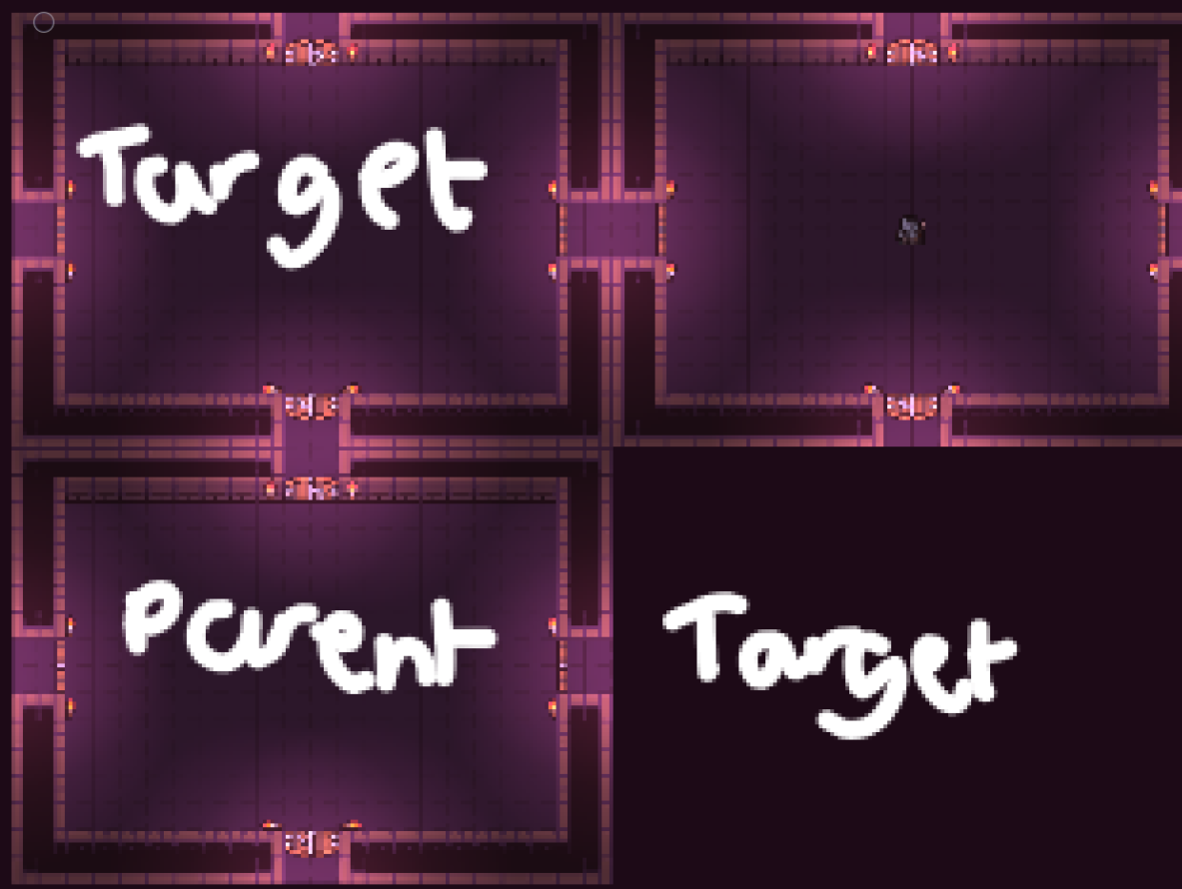

### Final Iteration Testing

This table shows all of the major issues that were encountered during the iteration. Any tests that required retesting have their solutions shown in the Implementation section of the iteration, below a detailed description of the error.

|  |  |  |  |  |
| --- | --- | --- | --- | --- |
| Test No | Test Name | Expected Outcome | Experienced outcome | Retest/Development required? (Y/N |
| 1 | Weighted list work | Number in the first array containing numbers 1-4 are multiplies by the respective index in the probability array | Weighted list is by multiplying arrays together. | N |
| 2 | Setting number of childRooms | Whenever a room is created, a random number between 1 and 4 is set to the childRooms variable. | Random index can be selected and set to the childRooms variable when the room is first created | N |
| 3 | Individual rooms generation | Individual rooms can be created and put into the game world by calling the create room method along with the game coordinate to create the room on | Room can be created by inputting the desired world coordinate | N |
| 4 | Room gen | Rooms get created and put into the game world according to their assigned coordinate relative to the parent coordinate | Rooms get created through the procedural algorithm into new positions to create a fully randomised map | N |
| 5 | Room collisions | Rooms do not get created on top of any other rooms that already exist | Rooms sometimes generate on top of each other | Y |

#### Retest No 1 - Doors

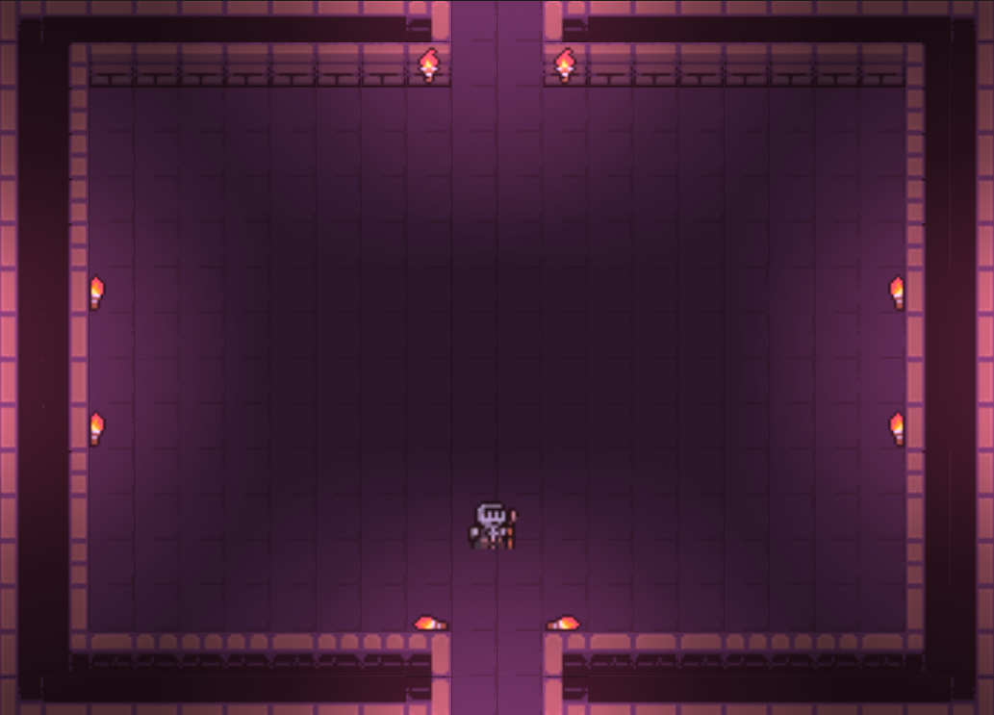

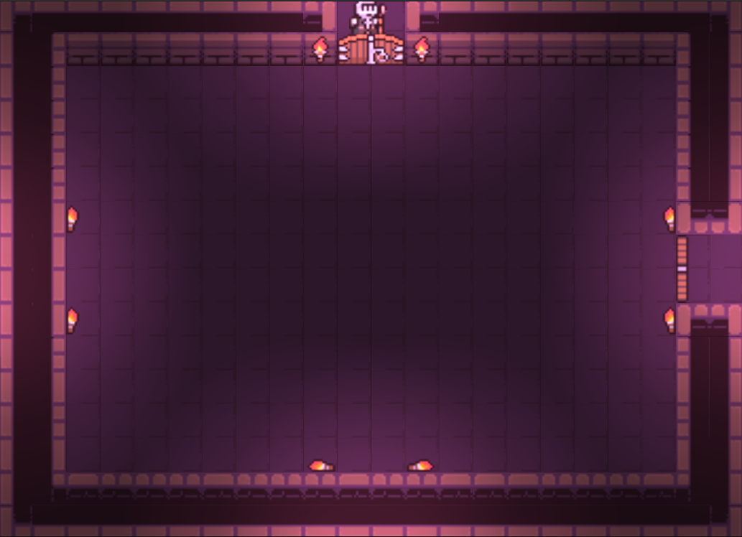

Doors mismatched, some open while some closed.

#### Setting number of Child Rooms

A small test was carried out here to ensure that the percentage chances for each potential number of children were working as intended.

This was done by setting up a key bind to reroll the number of child rooms, so that it could be tested multiple times.

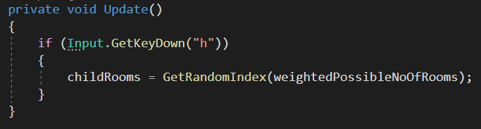

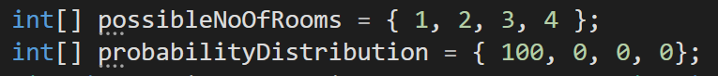

As shown above, the distribution of probabilities was changed to make it a 100% chance to generate 1 child room. This tested the integrity of the code by guaranteeing that it was being interpreted as intended and producing the correct result.

As shown below, the result of this was that the variable was only able to be set to 1, verifying the functionality of the code.

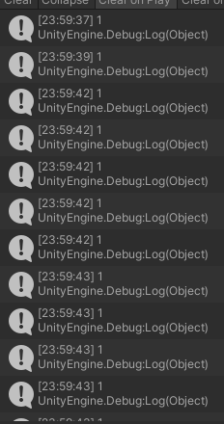

### Evaluation

## Iteration 4 – Enemies

### Iteration 4.1 – Enemy Spawning

#### Design

The first step of creating enemy movement is the spawning of enemies. This will be done by creating an area where enemies will be able to spawn within each room, and placing a set number of enemies within that area.

I can get the maximum and minimum values for the x axis by adding or subtracting half of the horizontal length to the x coordinate of the object respectively. The same can be done for the y axis by using the vertical height and the y coordinate of the object. The enemies will be picked randomly from the list of prefabs and instantiated into the room at a random coordinate, between 1 and 6 times as to not overcrowd the room.

Each of these enemies will be instantiated during map generation, with the enemies for a particular room being generated right after the room has been created. This will make it easier to implement as I can simply write the spawning code inside the Room class and have it created in the same area as the room, instead of having to calculate it afterwards, which would require checking through all of the rooms again and placing in enemies one at a time. This way, the code will be both easier to implement, and more efficient and well-optimised.

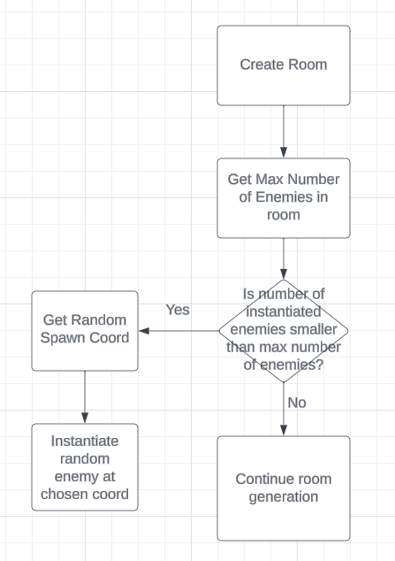

Above is a flowchart of the initial design of the process for instantiating enemies into a room. As with all other code in this project, the implementation will likely be much more complicated than this, and begin to require additional classes and methods, as I am dealing a lot with prefabs, which makes it difficult for referencing instantiated game objects, as the prefab isn’t actually initiated and does not exist within the scene.

The different scripts I will need to make this work will likely be contained within the RoomController class, for conversions between Room and World coordinates, and the game object for the play area that the enemies will be spawned into in each room.

#### Implementation

Within the Room class, I began by creating references to the required game objects and scripts. This was done as shown below.

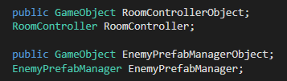

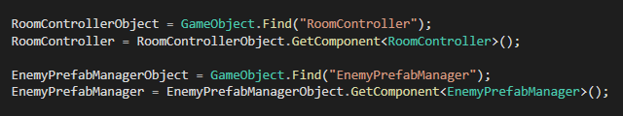

It took a small amount of time to get this working, as the Room class is only instantiated at runtime, meaning that existing game objects cannot be linked in the inspector. The way it ended up working was by creating two variables, one for the game object that holds the script we want, and one for the script itself. We then set the game object to the game object in the scene, and the script to the script component within that object.

Once that was working, the next thing to implement was the random coordinate system.

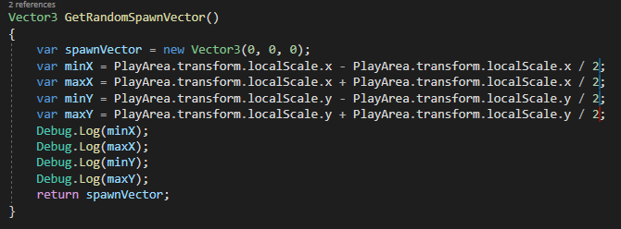

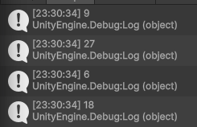

As shown above, this was implemented using some logic for the minimum and maximum values of x and y. This is the based on the fact that the playArea game object has a scale of (18, 12). The minimum value of x and y will be the full scale of the object, minus half of the scale, and the maximum value will be plus half of the scale.

#### Testing

|  |  |  |  |  |
| --- | --- | --- | --- | --- |
| Test No | Test Name | Expected Outcome | Experienced Outcome | Retest Required? (Y/N) |
| 1 | Get Components | Components are referenced within room | Can see components for room controller and enemy prefabs in the | N |
| 2 | Random Spawn Vector | Able to get a random spawn vector usable for instantiating enemies | Incorrect logic resulted in unusable vectors, however realised the need for a redesign. | Y |

#### Design – Test No 2

As per the failed test no 2, the random vector procedure required a design update that would allow it to be used with the world coordinate system, as the enemies will be instantiated based on the world coordinate of the room, plus the spawn vector. The vectors in the previous implementation did not return usable vectors.

The goal in this design is to create a procedure that can create positive and negative values from a fixed coordinate 0, that will be applied to the rooms centre coordinate to get a coordinate that resides within the room that an enemy can spawn in.

One way to implement this would be by having a constant vector 3 of (0, 0, 0), and applying either -9 or +9 to the x value for the minimum and maximum x values, and -6 or +6 for the minimum and maximum y values. This eliminates the need for unnecessary calculations when the calculation will be applying these minimum and maximum values to the rooms world coordinate to get a range of world coordinates that the enemy can spawn in for that room.

#### Implementation

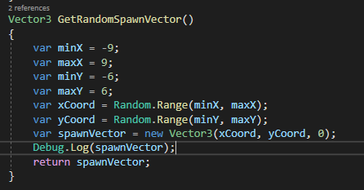

This is the updated version of the procedure. It uses 4 variables, primarily for ease of understanding, that have a random integer picked between them for the x and y values, those values are then plugged into a vector, and returned to be instantiated in the scene.

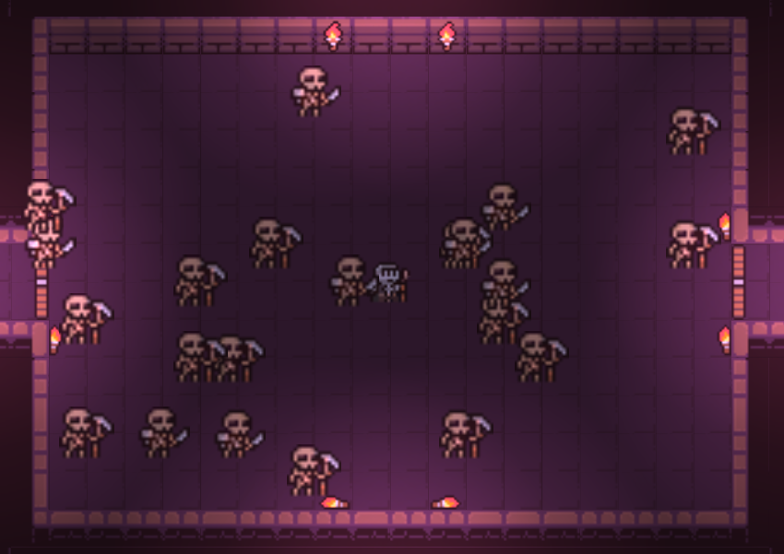

This is the result of the instantiation. Once the code has been applied to spawn them within their own rooms, they should not all spawn in the origin room.

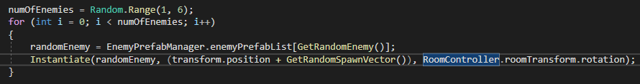

The code we used for the instantiation is shown above. To get them to spawn in their own rooms, we added the transform.position of the room to the spawn vector of the enemy. This gave the following result in game:

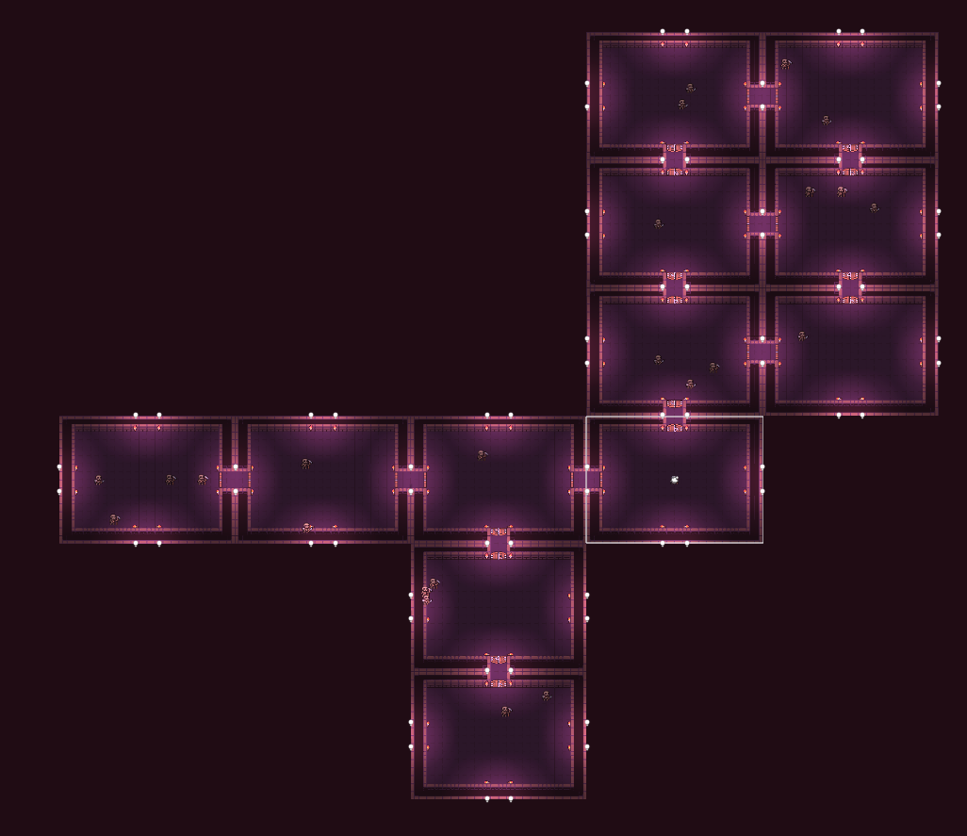

As you can see, each room has 1-6 enemies, with the maximum in this case having been 4 on the far left room. One minor alteration to this that I wanted to make was to ensure that the enemies did not spawn partially inside the walls. To do this I simply reduced the minimum and maximum values by 1 so that they would not spawn on the far edges.

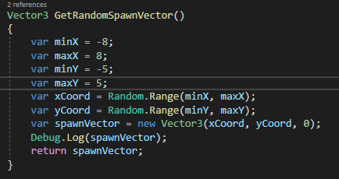

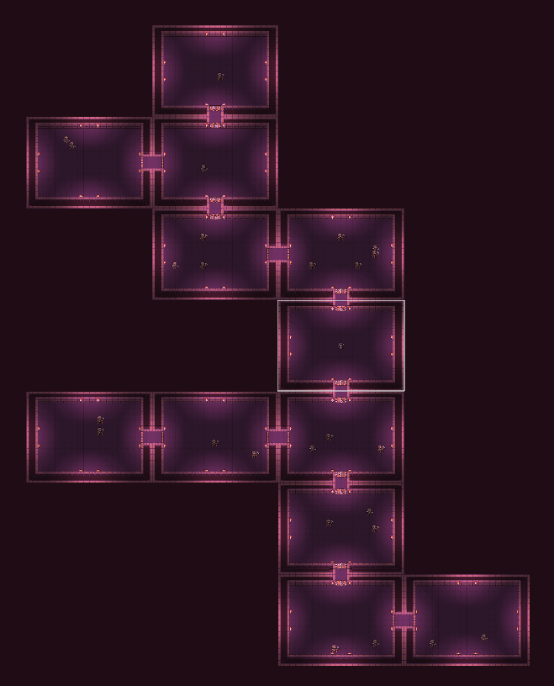

The enemies now spawn fully inside the rooms, without partially clipping through the walls.

### Iteration 4.2 – Enemy Movement

#### Design

When brainstorming ideas for how to manage enemy movement in the game, my initial idea was to use a package from GitHub that utilised different scripts on both the surface and sprite to create meshes that would allow for AI pathfinding to be implemented. While this would have worked, I decided against it in the hopes that I would be able to design my own algorithms to accomplish similar functionality. While it will likely not be as foolproof as the package, which allows for pathfinding past obstacles and blockages, that will not be an issue in my game as it current does not have that feature implemented.

This will mean that in the future if I wanted to add obstacles, I would have to reevaluate the use of pathfinding tools, as through research I have found that creating your own will be too time-consuming and will almost always be worse than one that has already been created considering how much time it would take to create yourself.

How it will be accomplished in this version of the game, will be setting a variable for the enemy’s room to the value of the parentRoom when the enemy is instantiated. This will be called on the start method of the enemy when it is created, so should not update even after the value of parentRoom has changed. The GetRandomVector will then be called, and the enemy will move towards that vector in the room over a period of time. Once it has done that, it will wait a short amount of time before choosing a new vector and moving to that. The random wait time will ensure that enemies move at all different times to make their movement less predictable for the player.

#### Implementation

The first thing I did in this iteration was move the methods relating to enemies into their own utility helper class.

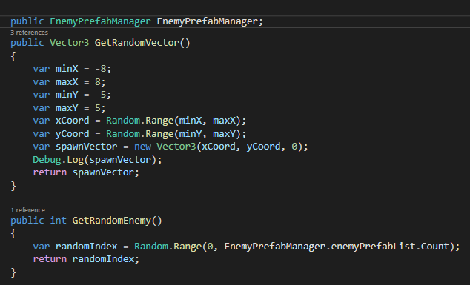

This allowed me to reference them both inside and outside already instantiated objects. This was necessary due to the fact that they were initially held inside a prefab. As I wanted to access them inside another prefab as well, this was the simplest way to make that possible, as I could not create a reference to non-instantiated object inside another non-instantiated object.

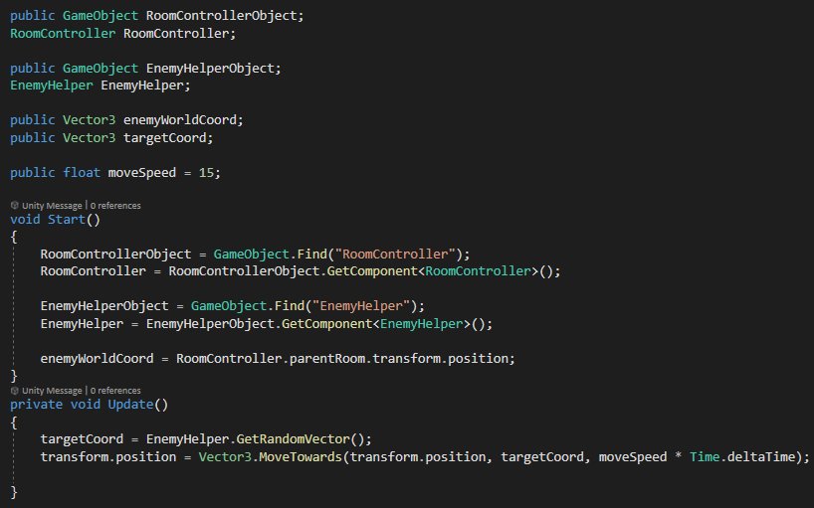

A short script was created for the initial implementation of enemy movement. This script started by setting the world coordinate of the parent room at the time the enemy was instantiated to the general coordinate of the enemy. A target coordinate was then created to set where the enemy will attempt to move to. The enemy’s position will then be set to move towards that target coordinate over a certain period of time, modifiable by the enemies move speed.

#### Testing

When testing this implementation, I found that all enemies were selecting coordinates at the origin room, causing them all to move, regardless of their location on the map, to the room at 0, 0. Once there, they would move very quickly around that coordinate as if they were selecting new target coordinates relative to the origin.

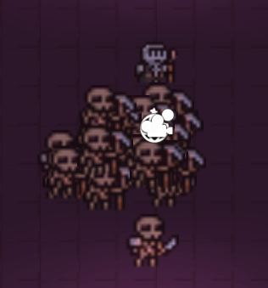

Aside from the issue of using the wrong coordinates, and the fact that there seems to be a conflict between the usage of room coordinates and world coordinates, the algorithm seems to be mostly functional. The issues will simply have to be fixed in a redesign and implementation.

#### Design

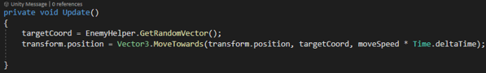

After some more testing, it was discovered that the quick changes of direction before meeting their set positions was due to the update function being called multiple times, not allowing the enemy to get to their new position before having a new one be selected. This took a while to figure out, as it was not a problem that I had had with the camera, as the player was unable to move fast enough to make the camera move again before it had reached its intended position.

The best way to approach a fix for this method is to run a check to see if the enemy has reached their destination before selecting a new coordinate to move to, preventing new coordinates from being generated every frame.

Alongside this, I wanted to add a wait time between movements where the enemies would be idle, as I found that they would immediately move to their next position once they had reached their target. While this is not an issue code-wise, I thought this implementation would improve the player experience significantly, as it gives them a chance to react to the enemy’s previous movement before they move again.

#### Implementation

#### Testing

#### Evaluation

## Iteration 5 – Enemy Attack

This version of the game will have 4 enemy types, Skeleton1, Skeleton2, Skull, and Vampire, as shown below.



Each enemy will have its own respective colour projectile, so that the user knows exactly what enemy is firing what, and to help with memorising attack patterns, as each enemy will have their own style of attack. Skeleton1 will shoot a single projectile, similarly to the player’s projectiles, but will aim them in the direction of the player at a given point. Skeleton2 will shoot 3 projectiles, at slower intervals, with the centre being set towards the direction of the player, with the 2 either side being shot 45 degrees to the left and right of the centre projectile. The skull will shoot projectiles in al 8 directions, and the vampire will shoot much slower projectiles, less frequently, that will instead deal 1 full heart of damage instead of the usual half a heart that the other enemies deal.

Each enemy will have their own specific enemy class for attacking, that will instantiate their respective projectiles in the patterns that they fire in. Each projectile will inherit the EnemyProjectileBehaviour class as a general projectile class for enemies, that will cause damage to the player when they collide with one. Each class will also have a specific projectile class that will determine the things such as the speed of the projectile, and any overrides for damage dealt if the projectile deals more damage than a usual projectile, such as the vampire’s.

### Iteration 5.1 – Skeleton1 Attack

#### Design

As mentioned, Skeleton1 will shoot a single yellow projectile towards the player’s current vector at the time of firing.

#### Implementation

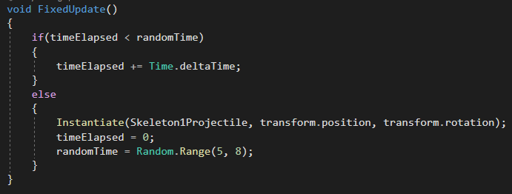

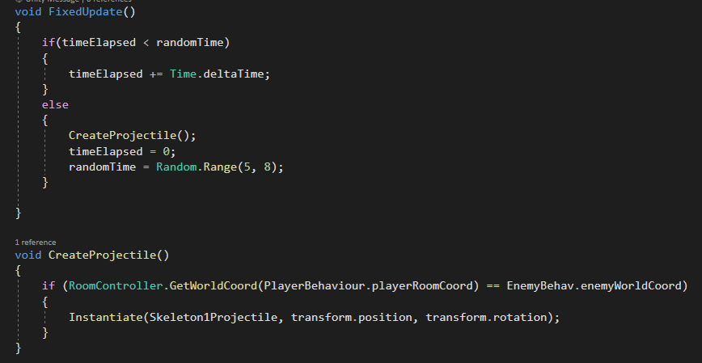

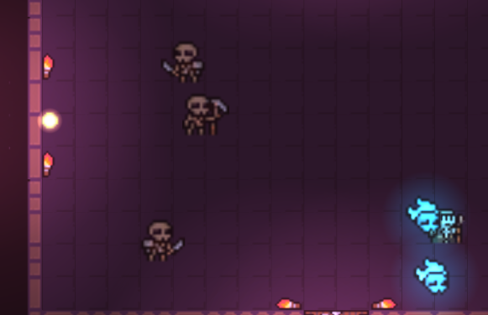

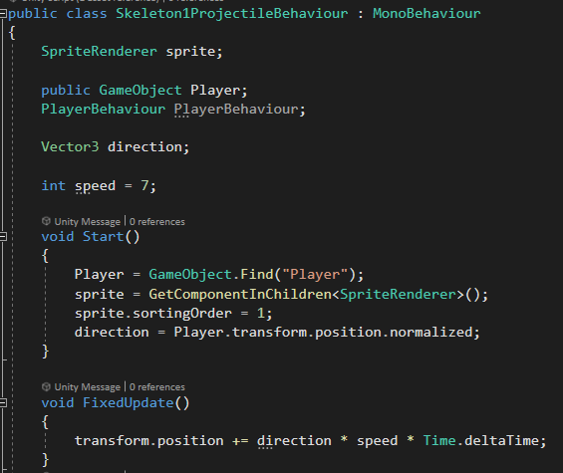

Always shooting in same direction towards the top left of the screen.

#### Testing

#### Evaluation

### Iteration 5.2 Skull Attack

#### Design

Since creating the first skeleton’s projectiles, I have realised that it would be better for the player’s experience if the skulls only shot projectiles in 4 directions, instead of 8. This is because there will be too many projectiles on the screen, especially once the other enemies have had their projectiles coded as well.

Here is a basic flowchart for the process of creating the skull’s projectiles.

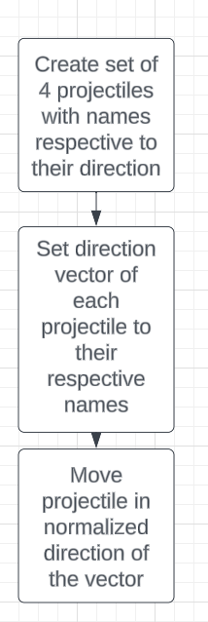

The simplest way to work this enemy’s projectiles is to create a prefab that already has the 4 projectiles in it, each with their own name for their direction. The behaviour class for the projectiles can then have variables within, referencing the children of the object, which will be each projectile. These projectiles will then be moved in their correct directions.

#### Implementation

First, a prefab of 4 skull projectiles was created.

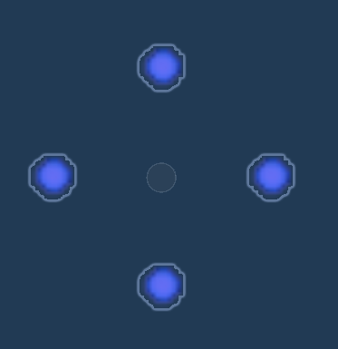

Initially, these were created all on top of each other in the prefab, however this made some issues arise when instantiating then on top of the skull, as they would all push away from each other as a result of the colliders, meaning I had to move them away from each other like I did with the player’s projectiles, with each one being 1.5 units away from the enemy in each direction.

#### Testing



#### Evaluation

### Skeleton2 Attack

### Vampire Attack

## Iteration 6 – Player and Enemy Properties, Player Upgrades

For time management purposes, I have decided to create the Player and Enemy Properties before finishing enemy attacks, due to the attacks being completable at any point in the project separate from the other features. By doing this, it will allow me to better sense the time I have left to complete the project, and how much time I have to allocate to each section to ensure it is all completed in a good amount of time.

### Design

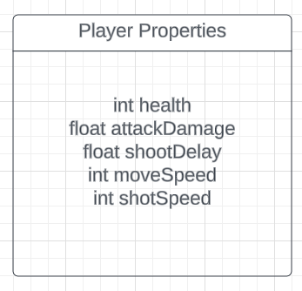

The initial player properties are as shown above. This should be all that is needed for both general gameplay, and upgrading the player’s stats as they progress through the game. Enemies will also be given a health property, with that being the only modifier that will change throughout the game, as the player hits them with projectiles. In order for the player to tell if the enemy has been hit, then the enemy will turn red once a collision with the player’s projectile occurs. This will be done utilising the enemy’s spriterenderer.

### Implementation

### Testing

### Evaluation

### Player Upgrades

<https://medal.tv/games/binding-of-isaac/clips/1VAKoei0cZD1Ne/d13377piQn0S?invite=cr-MSxBRE8sMjU2NTUwMTks>

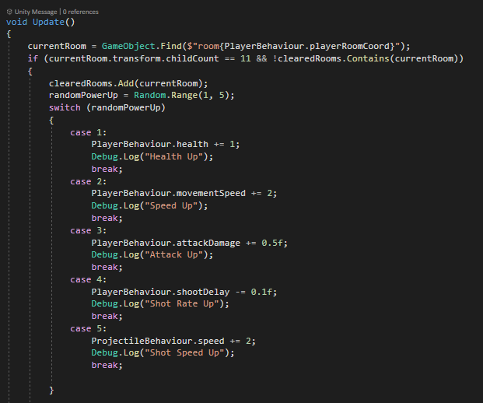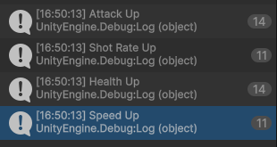

Fixed by adding a check to see if the name of the room matched the name of the room the player was in.



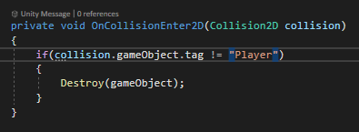

When increasing shot rate, the player’s shots would collide with each other and be destroyed due to the collision destroying the projectiles if they collided with anything other than the player. This was fixed by adding another condition, so that if they collided with another player projectile, they wouldn’t be destroyed.

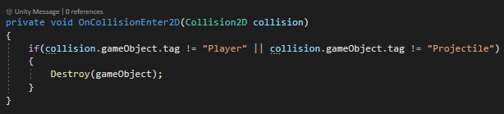

## Iteration 7 – User Interface

### Design

The final iteration in my game is the addition of UI. This is important for user experience, as well as the functionality of the game. The primary features I want to add within this iteration are a start and pause menu, allowing the user to both start a new game and quit to desktop within the start menu, and quit to the menu or desktop from the pause menu.

I also want to add a HUD for the player’s health, so that the player can always see how close they are to dying and can adjust their playstyle accordingly to either be more aggressive if they have higher health, or more preservative if they have lower health and are closer to dying. I had originally considered having a bar system for this, with vertical red bars in the top left corner, each one representing one unit of the player’s health, however there is a large time restraint at this point in development, so I have opted for an alternative approach, with an integer value being displayed alongside “HP:” to tell the player the number of hits they can take before dying. This will have a value of 6 at the start of the game, however it will have no upper limit, meaning that if a player gets a health up upgrade, a higher value than 6 may be displayed.

I also plan on adding banners to the game whenever the player picks up a new item. This banner will display for a few seconds before disappearing, with the upgrade having been given to the player simultaneously.

The final UI elements I want to add to the game are screens that display either when the player dies, or beats the game. The deaths screen will display whenever the player’s health reaches 0, allowing them to either go back to the main menu, or quit to the desktop. The win screen will display when all rooms have been cleared

I plan on utilising scenes to accomplish these tasks. I will have to create an individual scene for each player upgrade, the start and pause menus, and the player health. Each scene will be designed using UI game objects held within the Unity engine, making UI creation much easier than having to draw it out manually.

For the UI, there is a package called UI, which is preinstalled with the Unity engine. This will be used within all classes that deal with the game’s UI, as it enabled options for button usage, which is used to a great extent within the menus.

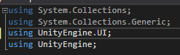

The SceneManagement package will also be used within the development of the UI to load and unload scenes as necessary. This is required as there are no other packages that come already in use within Unity classes that allow for the manipulation of game scenes.

Each scene within the game will have its own name relating to its purpose. These name will then have to be referenced when loading the scenes in the backend of the game.

#### Start Menu

The start menu will have 2 buttons on it. One to start the game and load the player into the procedurally generated map, and one to close the game back to the desktop. Each button will be created using a button component on a panel containing the text, with a click event written into the backend of the button. For the start button, this click even will tell the game to load the player health scene, and the map scene. For the quit to desktop button, it will simply quit the application.

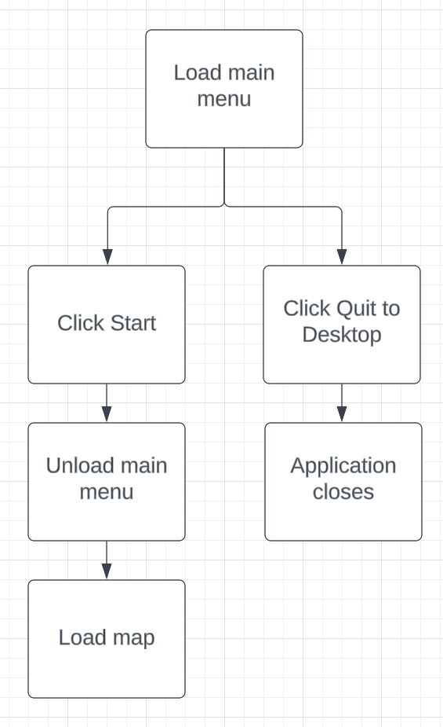

#### Pause Menu

The pause menu will have one more option than the start menu. As the player will already be the in the game, they will not need an option to restart as there is already a feature in place where holding the R key for a few seconds will reload the map with a newly generated one.

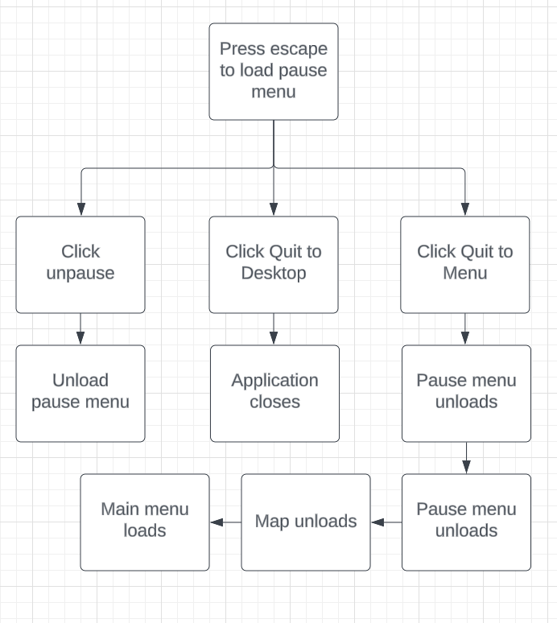

##### Pausing and unpausing

I needed to think of a way to make the menu open and close whenever the player clicked the escape button. The best way to do this would simply be to add an if statement that is called every frame, checking for an input of the escape key. Once the input has been received, it will check to see if the pause screen is already loaded. If it is not, then it will load the pause scene on top of the current map scene. If it is, then it will unload the scene from the game. This method of pausing and unpausing the game is to improve the user experience of the game, so they do not have to reach over to their mouse to unpause the game once it has been paused, and can instead just repress the pause button. Whenever the game is paused, the gametime will be set to 0 to complete pause the game, and when it is unpause it will be reset to 1.

There will also be an unpause button on the menu that will achieve the same functionality as pressing the escape key again while the pause menu is displayed.

##### Quit to Menu button

The next button will be a quit to menu button. This will follow the process as shown in the flowchart above, where once the button is clicked, the pause screen will be unloaded, after setting the gametime back to 1. After this, the map will unload and will be replaced with the main menu, allowing the original full functionality of the main menu, where the user can either start a new game or quit to the desktop.

##### Quit to Desktop Button

Much like in the main menu, there will be a quit to desktop button, that the user can click to immediately quit the application, sending the user back to their desktop. This will be done using Unity’s built-in method for quitting applications.

#### Health

The player’s health will be displayed with a scene, and a text box whose text will be the variable that holds the player’s health. This will be updating every frame of the game as an integer value within the scene, immediately reflecting the player’s health whenever they get hit or get a health up upgrade. This scene will be loaded alongside the map scene, whenever the player clicks “Start” on the main menu.

#### Power-up Pop-ups

Whenever the player clears a room and receives a power-up, I wanted to add a pop-up banner so that the player could tell which power up they got without having to look in the console, which was the previous system I had in place along with the health and win messages, as this would not be visible in the game while it is running in a production build.

The best way to approach this would be to create a different scene for each of the individual powerups, making it easy to load the respective scene whenever a power-up is given to the player, display it for a few seconds, and then close it by utilising an IEnumerator method, making the program wait before executing the next lines of code, which in this case, would close the banner.

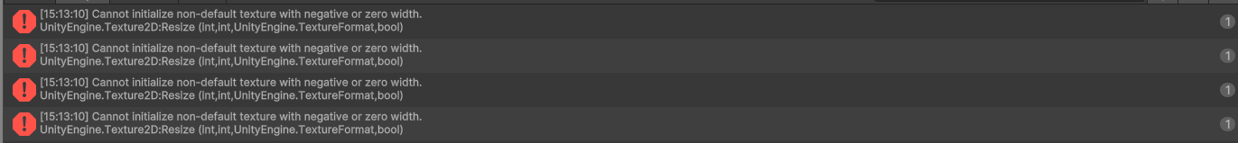

This error was fixed by changing the version of Unity that the project was running on. It turned out that this was a known bug in version 2023.1. After I updated this to 2023.3, and reimported the text packages, this issue no longer occurred.

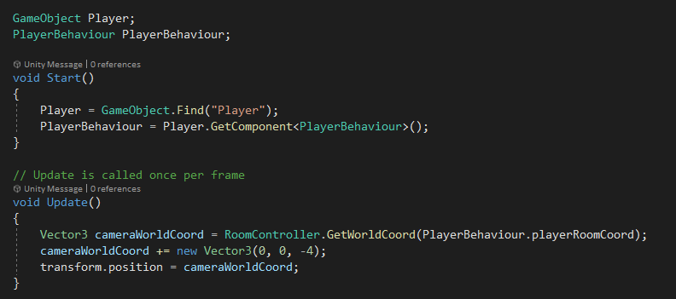

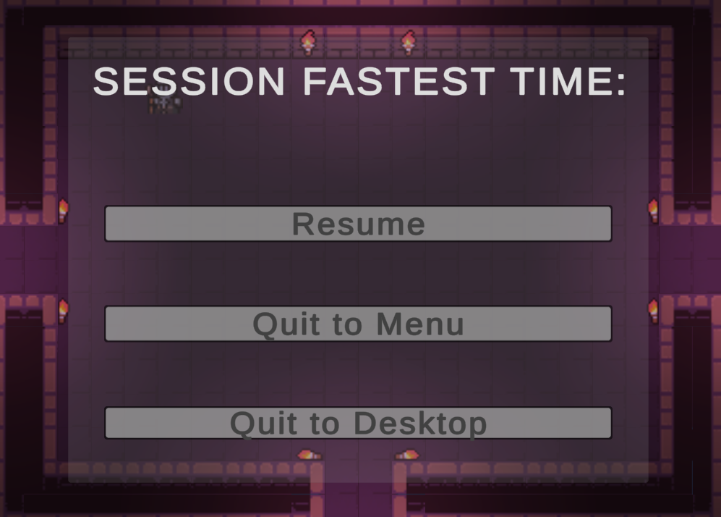

### Implementation

#### Creating Scenes

The first step of implementation for this iteration was creating all of the scenes discussed in the design section. I decided to design these for the first time within the Unity editor, as anything made outside would not be able to be replicated exactly, and I knew that the menus would be relatively basic for a game such as this.

### Testing

### Evaluation

## Iteration 8 – Modifying Door behaviour

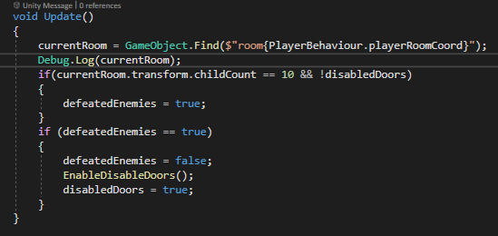



# Bibliography

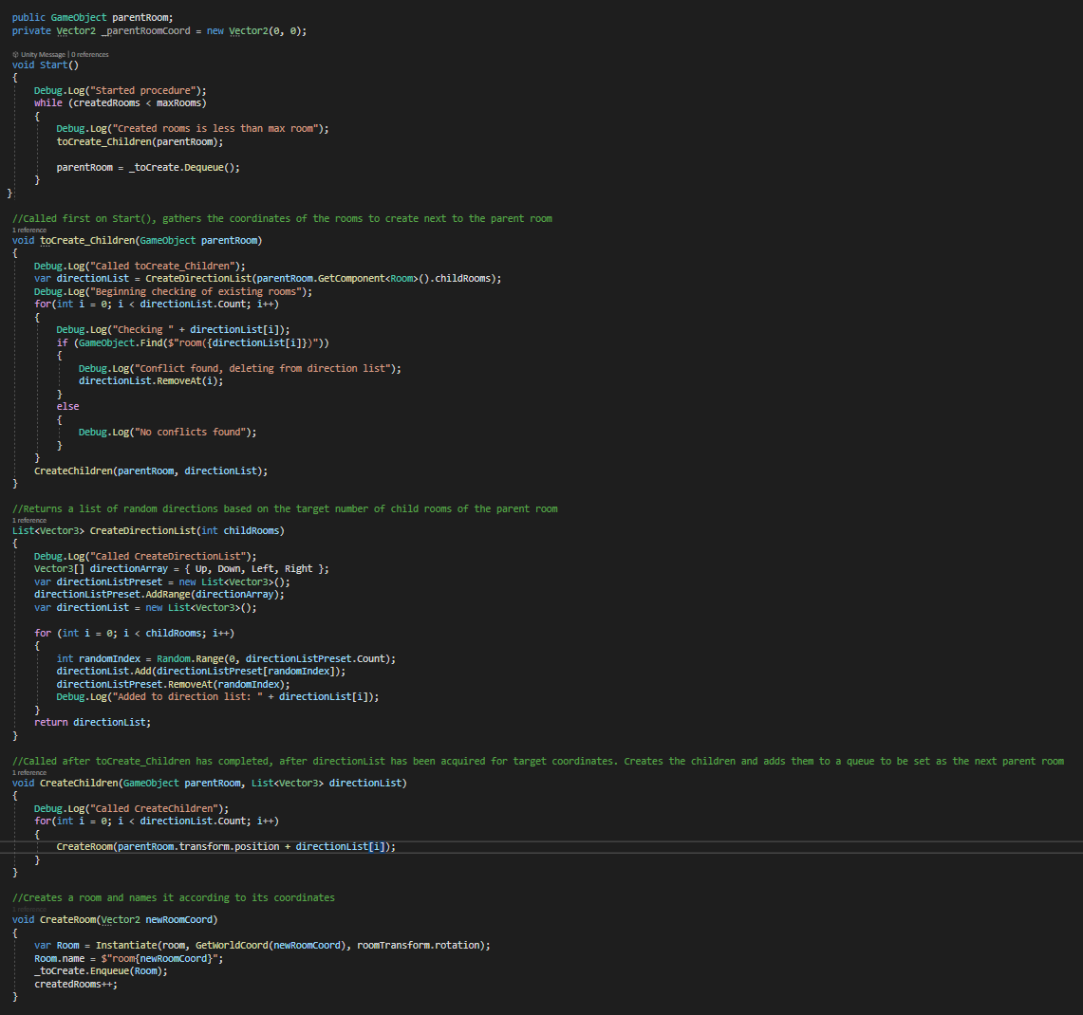

## Explanation of Initial Attempt

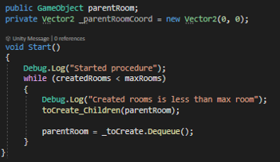

Within the start method of the algorithm, there is a check to ensure that the code within will only execute if the maximum number of rooms has not been reached. If it has, it will create the children of the parent room as assigned before the start method. This will only be the case for the first iteration of the algorithm, as after the toCreate_Children method has been called, the parent room is set to the value given from dequeuing the _toCreate queue.

